[Escaping the Dungeon!](https://thealexandrian.net/wordpress/2149/roleplaying-games/escaping-the-dungeon)

February 17th, 2009

I’m in the early stages of prepping a new fantasy campaign. One of the specific design goals is that the campaign needs to be able to handle a variable group of players. That means, for the sake of verisimilitude, it’s important that — at the end of any gaming session — the PCs are no longer in the dungeon. (In other words, they need to be in a position where it’s easy to explain why — since player X can’t attend the session — character X isn’t part of the adventure next week.)

Towards that end, I am instituting a simple rule of table etiquette. There are three ways in which a gaming session can end:

(1) The players can, at any time of their choosing, make their way out of the dungeon and end the session for the evening.

(2) As the GM I can, at any time of my choosing, announce that we will stop playing in 1 hour. If, by the end of the hour, the PCs have made their way out of the dungeon, the session ends normalyly.

(3) But if they have not made their way out of the dungeon (for whatever reason), then either (a) everyone in the session can immediately commit to another session within 7 days; or (b) the Escaping the Dungeon! tables will be used to determine their fate.

The *Escaping the Dungeon!* tables were designed, with a tip of the hat to [Jeff Reints](http://jrients.blogspot.com/2008/11/dungeons-dawn-patrol.html) for the inspiration, to be used determine the fate of PCs left in the dungeon at the end of the session. At the GM’s discretion they may also be used for some wilderness situations. (For most wilderness situations, I anticipate being able to use PBeM to resolve the journey back to the home base of the PCs.)

**ESCAPE CHECK**

| **SITUATION** | **CHANCE OF ESCAPE** |
| --- | --- |
| You don't know where you are. | 25% |
| You know where you are. | 50% |
| You have a clear and unhindered path of escape. | 75% |

**CHALLENGE ADJUSTMENT**: Adjust the chance of escape by +/- 10% multipled by the difference between the average CR of the local opposition and the level of the character. (For example, a 5th-level character facing CR 7 opponents would suffer a -20% adjustment on their chance of escape. In a classic dungeon scenario, you can make this adjustment using the dungeon level — a 5th-level character on the 3rd level of the dungeon would enjoy a +20% adjustment on their chance of escape, for example.)

**SMALL COMPLEX**: If the characters are attempting to escape from a lair or other small complex, increase the chance of success by 10% to 20%.

**MAKING THE CHECK**: An escape check is made for each character separately. There is always a minimum 1% chance of escape or failure. On a failed escape check, roll 1d10 on the *Failed Escape* table below.

**FAILED ESCAPES**

| **1d10** | **RESULT** |
| --- | --- |
| 1 | You escape unharmed. |
| 2 | You escape but have been permanently altered (maimed, permanently polymorphed, replaced with a double, etc.). |
| 3 | You escape but have been injured. You suffer 1d6 x 1d6 points of damage. (If this kills you, see result #8.) |
| 4 | You have lost 1d6 pieces of equipment. Determine randomly between slots and bags. If a bag is lost, all of its contents are lost with it. |
| 5 | You have been captured, petrified, or otherwise trapped. Roll the escape percentile again to see if your comrades know where you are. If they do not, roll the escape percentile again to see if your comrades have a clue of some sort. |
| 6 | You have become lost. |
| 7 | You have been transformed into a monster (undead, lycanthrope, mind controlled, etc.). |
| 8-9 | You have died. Roll the escape percentile again to see if your comrades were able to retrieve your body. (Instead of retrieving your body, your comrades may choose to loot it and/or leave it.) If they did not, roll the escape percentile again to see if your comrades know where your body is. If they do not, there is a 50% chance that your body has been utterly destroyed. |
| 10 | Opportunity for betrayal. You can choose to either reroll on this table or betray a comrade who would otherwise escape. If you choose to betray a comrade roll 1d6 -- on a roll of 1-4, you escape and they must roll on this table; on a roll of 5-6, both you and your victim suffer the fate they roll. |

**DESIGN NOTES**

The primary goal of this little sub-system is not to punish the players. However, it is designed to provide them with a meaningful motivation to leave the dungeon in a timely fashion. Failing that, it is designed to provide interesting consequences that (frequently) can be followed up on subsequent forays into the dungeon — whether that’s recovering lost equipment, ransoming a lost comrade, or the like.

The actual chance of outright dying, you’ll note is quite slim. If the escape check is the standard value of 50% (and it will usually be higher), then your chance of dying is only about 10% vs. a 55%

The results of the *Failed Escapes* table, it should be noted, are meant to be flexibly interpreted by the GM given the exigencies of the specific situation in which the PCs find themselves at the end of the session. The creation of a short fable explaining the events leading to their escape (or lack thereof) — perhaps even one garnering them with some bit of lore or insight into the dungeon complex — would not be out of place.

And, of course, the table is specifically designed to be used in a very specific type of old school inspired campaigning. In most of my campaigns I have no problem hanging out the reliable “To Be Continued” placard.

<https://thealexandrian.net/wordpress/2149/roleplaying-games/escaping-the-dungeon>

[Putting the “Magic” in Magic Items](https://thealexandrian.net/wordpress/2557/roleplaying-games/putting-the-magic-in-magic-items)

February 9th, 2009

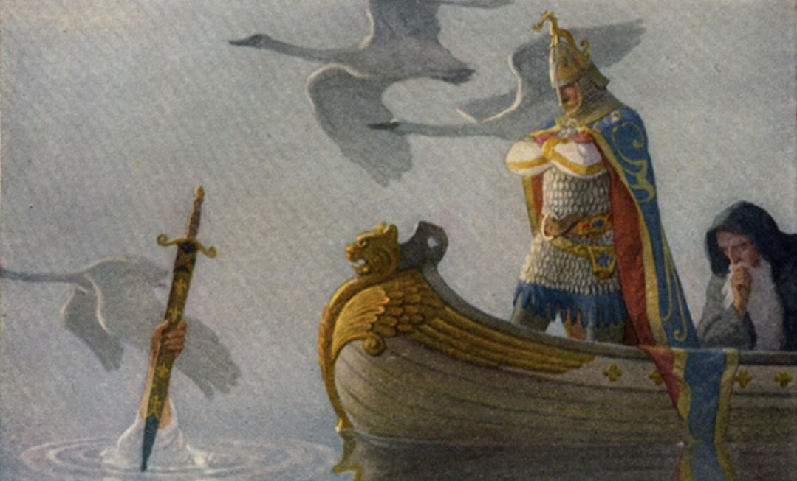

D&D — and roleplaying games in general — have always struggled with magic.

Elrond knew all about runes of every kind. That day he looked at the swords they had brought from the trolls’ lair, and he said, “These are not troll-make. They are old swords, very old swords of the High Elves of the west, my kin. They were made in Gondolin for the Goblin-wars. They must have come from a dragon horde or goblin plunder, for dragons and goblins destroyed that city many ages ago. This, Thorin, the runes name Orcrist, the Goblin-cleaver in the ancient tongues of Gondolin; it was a famous blade. This, Gandalf, was Glamdring, Foe-hammer that the king of Gondolin once wore. Keep them well!” — *The Hobbit* by J.R.R. Tolkien

Nifty.

Player: We search the trolls’ lair.  
DM: You find a *+1 goblin-bane longsword* and a *+3 longsword*.

Less nifty.

Some would conclude from this that D&D just doesn’t do magic very well. After all, what’s magical about a +2 bonus to attack rolls or a +5 bonus to Hide checks?

But let’s consider this problem from another angle.

He saw a tall, strongly made youth standing beside him. This person was as much out of place in that den as a gray wolf among mangy rats of the gutters. His cheap tunic could not conceal the hard, rangy lines of his powerful frame, the broad heavy shoulders, the massive chest, lean waist, and heavy arms. His skin was brown from outland suns, his eyes blue and smoldering; a shock of tousled black hair crowned his broad forehead. From his girdle hung a sword in a worn leather scabbard. — “The Tower of the Elephant” by Robert E. Howard

Also nifty.

DM: Someone taps you on the shoulder.  
Player: I turn to look. Who is it?  
DM: A 3rd-level barbarian with a sword.

Similarly less nifty.

What are we supposed to conclude from this? That roleplaying games are just abject failures? That they suck all the life and mystery and grandeur from the world?

Well, they certainly can do that. If you let the numbers *become*the game world, then that seems to be the inevitable result. But I think we’re only looking at half the story here. In my opinion, the numbers inherent to a roleplaying system are only a means to an end. They shouldn’t be confused with the game world — they are merely the means by which we interface wtih the game world.

So, yes, the blade we found in the troll lair was, in fact, a *+1 goblin-bane longsword*. That doesn’t change the fact that it is *also*Orcrist, the Goblin-cleaver of Gondolin — a legendary blade lost to the elves when that proud city fell to dragons and orcish hordes.

The numbers are only empty and meaningless if you leave them that way. If you fill them with meaning (or start with the meaning and work your way back to the numbers), the problem goes away.

With that thought in mind, here are a few methods for spicing up your magic items.

**HOW DOES THE MAGIC WORK?**

Mechanically, a *+2 longsword* magically gives you a +2 bonus to your attack and damage rolls.

Okay, but what does that *mean*? Is the blade preternaturally sharp? Does the magical enhancement guide your thrusts? Does it grant you a moment of combat-oriented prescience at the moment you begin to swing your blade, allowing you to see the outcome of the stroke and adjust it accordingly? Is it perfectly balanced, yet light and lively in your hand? Does the edge of the blade morph from diamond sharpness (for piercing armor) to vicious serrations (to rip and tear at flesh) in the middle of a blow? Can you feel the tendril of its mystic energy reaching into your mind and there implanting the arcane combat techniques of the Obsidian Brothers — techniques that you can scarcely comprehend? Does your arm grow in strength and speed when you hold the blade? Does the blade glow with a light that only you can see, but which seems to limn your targets in crystal clarity?

In my current campaign, one of the PCs has a*ring of lockpicking* (+5 bonus to Open Lock checks). The ring has a large ruby that can be slid to one side, revealing a nest of miniature tools. The wearer of the ring can mentally manipulate these incredibly precise tools (hence granting the bonus to their skill checks).

But you could just as easily have a *ring of lockpicking* that grants the wearer an encyclopedic knowledge of locks; or allows the wearer to psychically “feel” the mechanisms of the lock; and so forth.

The difference between a ring that grants an enhancement bonus in some vague and unspecified way (“’cause it’s magic”) and a ring filled with magically-crafted tools that you can control through the power of your mind is a vast gulf of detail and personality. And having a firm understanding of not only what the item does, but *how it does it*, can turn every use of that item into a flavorful and memorable event.

**NAMES**

Nobody remembers Magic Sword #3419. But if I say “Sting”, you probably think Frodo. And if I say “Stormbringer”, you probably think Elric.

Naming an item immediately makes it unique. It also gives the item an identity, which means that the item will immediately begin accumulating lore to itself — every time something interesting or memorable happens involving the item, it has a name that can be latched onto that event.

There are basically two ways for an item to gain a name:

(1) Lore. Like Glamdring or the Ruby of the North, the item may have been given a name before it ever comes into the hands of the PCs. This lore-born name can be imparted to them in many ways — perhaps the ogre wielding the weapon cries the name aloud; or the item whispers it in their ear when they first claim it; or a loremaster identifies it; or they were questing for it; or they know it themselves (from a successful skill check).

(I just made up the name “Ruby of the North”, but it made you wonder what it was, didn’t it?)

(2) New. Encourage the players to name items that are important to them, or seize opportunities to immortalize memorable events in the game by naming the items responsible for them. When a sword becomes Gnoll-Render because of the PCs ripping out the entrails of the gnoll chieftain… well, that’s pretty awesome.

**UNIQUE APPEARANCE**

If magic items look generic, then they’ll be treated generically. If *+2 longswords* just look like every other sword (or even if every +2 longsword just looks like every other *+2 longsword*), it doesn’t matter how rare they are — they’re still going to be treated as nothing more than a stat block.

For example, several months ago one of the PCs in my campaign went down to the local magic shop to buy a magic sword. What could be more generic, right?

When they first arrived in the shop and started talking about weapons, the shopkeeper showed them several magetouched weapons that had recently been recovered from the depths beneath the city. But when it became clear that they were seeking something a little more notable, he smiled enigmatically and went into a backroom.

He emerged with a long, slim blade. The steel was filigreed with gold and the hilt was of finely curved silver. He ran his hand gently down the length of the blade, as if caressing a lover. “The markings here upon the blade are not merely gold, but taurum — the true gold, mined from the Mountains of the East. And there is a thin core of it in the heart of the hilt. The enchantment worked upon this blade sings from the taurum, and its name is Nainsyr.”

At the word, blue lightning sprang from the hilt and rang along the length of the blade — crackling with a vicious smell of ozone.

“It’s an elvish word. It means, ‘Let there be lightning.’ And, indeed, the blade is old. It shows the marks of an elvish craft that I have rarely seen.”

It’s a *+1 shock longsword*. And it was bought in a store. But it’s *his sword*. The players remember who they bought that sword from. They remember the first time the PC used it in combat.

Another example from my campaign is a *bag of holding* elegantly crafted from black velvet that was given to the party as part of their payment for a job well done. This unique little touch might not seem like much, but not only do the players distinctly remember receiving that payment, the player who carries the *bag of holding* has actually passed up the opportunity to get larger *bags of holding* simply because they like this one so much.

**HISTORY**

Glamdring and Orcrist have a history to them. They existed before they came into the hands of the heroes. They are spoken of in tales.

Giving a magic item a unique history — much like naming them — helps to give the item an identity. It can also make the players feel like their characters are inheriting a meaningful legacy or a sacred trust. It gives the item meaning, purpose, and context. This item is not merely a tool; it is a thing of note.

**MECHANICS**

Most of this essay has dealt with how to make magic items feel special and magical in spite of the mechanics. But you can also turn the mechanics to your own use.

For example, *+1 shock longsword* is not only mechanically more interesting than a *+2 longsword*, that special ability also gives you something to latch onto while using the other techniques described here. (For example, *Nainsyr’s*taurum filigree and name are all derived from its special ability.)

Items which feature an interesting package of abilities or a quirky side-effect can be notably unique. A *ring of water-breathing* that turns the skin of the wearer blue; an *amulet of health* that causes the user to exude a golden glow (with the effect of a *light*spell); winged boots that spontaneously generate a cloud of butterflies that flutter around the user; a fist-sized ruby that functions as both a *crystal ball* and a *gem of seeing*; and so forth.

**MANAGING THE DETAILS**

All of this advice can really be boiled down to a simple maxim: Life is in the details.

The difference between a cold, lifeless stat block and a memorable myth is all about the living details that you imbue your game world with.

But supplying this detail can seem a little overwhelming. Do I really expect you to give every magical item a clever mechanism of operation; an interesting name; a unique appearance; and a fully detailed history?

No, actually, I don’t. In fact, unless your campaign is *extremely*light on magical items, that would be a really bad idea. Not only will you end up overloading your players with details (to the point where they’ll just start tuning it out), but when *everything*is special and unique nothing ends up being special and unique.

In a magic-rich environment, not all magic needs to be unique or clever. For example, in my own campaign there are plenty of two-bit wizards who lay minor enchantments and charms onto blades. These “magetouched weapons” (as I call them) are, figuratively speaking, a dime a dozen. They’re magically sharp and strong, but they’re not particularly remarkable.

The other thing to remember is that you don’t actually have to do that much work. It’s easy to over-think things, but there’s really no need to prep a three page (or even three paragraph) description of a magic item.

Take Nainsyr for example. It has a little bit of history to it: It’s an old blade of rare elven craft and it was found by delvers plumbing the cavernous depths beneath Ptolus. That type of detail is easy to improvise (and, in fact, it was improvised — I didn’t know they were planning to go shopping).

That may not seem like a lot of history to you, but take a second look at Gandalf’s Glamdring: It seems to echo with history, but the only thing Tolkien actually tells you about it is, “It was worn by the king of Gondolin. It might have been taken by goblins or dragons during the sacking of that city.”

Tolkien lets your imagination run wild with that. Feel free to let your players do the same.

And did you notice how Tolkien doesn’t actually give the history of those weapons until *after*the heroes have already decided to wield them? Let the players tell you what they care about before you spend time working out the details.

**MINOR MAGIC**

As a a final word, let me point out that not all magic has to be usable. (Or, at the very least, usable by adventuring PCs.)

A small, well-worn stone that grows warm to the touch when you rub it. A poppet that moves and speaks when placed in the arms of a virgin. A skull that crumbles to dust when touched by living flesh, but then reforms itself over the course of 13 hours. A glass eye that rotates and spins when left unattended (in an eyesocket it rotates to perfectly mimic a living eye, although it conveys no gift of sight). A blindfold that can be seen through as if it wasn’t there.

Some such items might be assigned some sort of market value (and, thus, become part of the treasure — albeit more interesting treasure than just X number of gold pieces). But their real function is to fill the world with a little bit of magic that just can’t be boiled down to, “What can I do with it?”

Sometimes magic is just… magical. It’s not there to be used as a weapon or beaten into a plowshare. It’s just there for the sake of being.

And when that type of magic permeates your campaign world — when wonders are there to be found… Well, that’s when you get magic in your magic items.

<https://thealexandrian.net/wordpress/2557/roleplaying-games/putting-the-magic-in-magic-items>

[Design Notes: War-Trained](https://thealexandrian.net/wordpress/4169/roleplaying-games/design-notes-war-trained)

March 27th, 2009

[RPGNow](http://www.rpgnow.com/product_info.php?products_id=50199&filters=0_0_0&manufacturers_id=2142) – [Lulu PDF](http://www.lulu.com/content/1142087) – [Print Edition](http://www.lulu.com/content/1141723)

[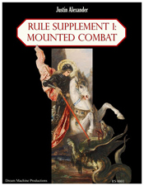](http://www.rpgnow.com/product_info.php?products_id=50199&filters=0_0_0&manufacturers_id=2142)I had a conversation this afternoon that reminded me of something I meant to talk about many moons ago regarding the development of [*Rule Supplement 1: Mounted Combat*](http://www.lulu.com/content/1141723).

Here’s the question that jogged my memory: “Is a familiar proficient in the same armor as the caster?”

This, it turns out, is not an easy question to answer. It ends up falling into the middle of several rather murky portions of the rules. The [Animal type](http://www.dandwiki.com/wiki/SRD:Animal_Type) in the SRD reads: “Proficient with no armor unless trained for war.”

The first complication with this is that familiars aren’t actually Animals, they’re Magical Beasts. And the [Magical Beast type](http://www.dandwiki.com/wiki/SRD:Magical_Beast_Type)simply reads: “Proficient with no armor.” So what happens if you take a war-trained animal and make it a familiar? Does it simply lose the proficiency?

The answer to that is: Maybe. The rules for familiars read, “A familiar is a normal animal that gains new powers and becomes a magical beast when summoned to service by a sorcerer or wiard. It retains the appearance, Hit Dice, base attack bonus, base save bonuses, skills, and feats of the normal animal it once was, but it is treated as a magical beast instead of an animal for the purpose of any effect that depends on its type. Only a normal, unmodified animal may become a familiar.”

You’ll note that proficiencies are not listed in the list of things that the familiar retains when it becomes a magical beast. But, on the other hand, proficiencies can also be a type of feat — should all proficiencies be grouped under that catch-all? I’d certainly argue that this interpretation of the passage makes the most sense.

But the passage also says that “only a normal, unmodified animal” can become a familiar. Is a war-trained animal a “normal, unmodified animal”?

Good question. What *is* a war-trained animal?

And here we come to the second murky area of the question: The term “war-trained” is never actually defined in the rulebook. The term is used in the Animal type (quoted above) and in a few scattered references to warhorses vs. normal horses, but it’s never explained. You would think since it involves training an animal that it would be referenced in the Handle Animal skill… but no such luck.

This was an issue that I needed to resolve for *Rule Supplement 1: Mounted Combat*. The way I resolved this issue was to create the War-Trained animal purpose. Animals could be trained with this purpose using the Handle Animal skill:

**War-trained** (DC 20): A war-trained animal knows the tricks attack, come, defend, down, guard, and heel. War-training an animal takes six weeks. You may also “upgrade” an animal trained for riding to a war-training by spending three weeks and making a successful DC 20 Handle Animal check. The new general purpose replaces the animal’s previous purpose. A war-trained animal is proficient with all armors (light, medium, and heavy) and shields (including tower shields).

Problem solved. If you adopt this War-Trained animal purpose as a fix-it for the oversight in the core rulebooks, then I don’t think it’s too much of a leap to allow a familiar to be war-trained (even though they’re technically magical beasts and not animals).

However, the may not be necessary if you’re willing to make a sufficiently liberal interpretation of the rules for familiar. Those rules state that familiars gain the skill ranks and save bonuses of their masters. Proficiencies aren’t mentioned, but that’s likely because (a) standard familiars can’t use weapons and (b) sorcerers and wizards aren’t proficient in any armor. I don’t think it’s too much of a stretch to allow for the familiar to gain the armor and weapon proficiencies of their master.

After all, it allows for awesome things like this:

[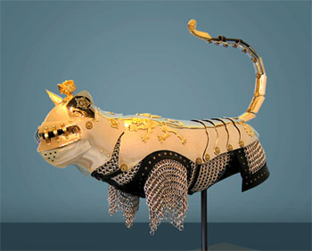](http://www.designverb.com/wp-content/images/2008/02/jeffdeboer.cat2.jpg)

And awesome should always win out in the end.

<https://thealexandrian.net/wordpress/4169/roleplaying-games/design-notes-war-trained>

[Thinking About Morale](https://thealexandrian.net/wordpress/2477/roleplaying-games/thinking-about-morale)

January 27th, 2009

James Maliszewski at [Grognardia](http://grognardia.blogspot.com/2009/01/dwimmermount-begins.html) has spoken at various times about the Moldvay morale rules. (Tom Moldvay being the TSR designer responsible for the 1981 edition of the D&D Basic Set.) James even went so far as to say that “D&D combat only makes sense if you assume the use of morale”.

This is an interesting thought. It was one that I initially rebelled against when I first read it, but it’s been kind of churning around in my head for a few weeks now. It’s been one of those memes that just refuses to let go.

I think the reason I mentally rebel against it is that it impinges into my “zone of GM control”. When I GM, I make a point of roleplaying the monsters. Hurt a wild animal badly enough and it’ll give up… unless it’s rabid. Get a one-shot kill on the goblin chieftain and at least some of the goblins are likely to rout.”

A morale mechanic has always seemed like a fairly crude way of modeling this behavior.

On the other hand, I understand James’ point: If you don’t take morale into consideration, D&D combat — particularly the classic D&D combat he’s talking about (when 0 hit points meant dead) — always ends in a slaughter. No quarter is ever given; no prisoners are ever taken. Once you start fighting, everyone keeps fighting until they’re dead.

For those who don’t have access to the 1981 Basic Set, these were Moldvay’s morale rules:

Any creature in battle may try to run away or surrender. Characters are never forced to do this; a character always reacts in the way the player wishes. NPCs and monsters, however, may decide to run away or surrender. To handle this situation, each monster is given a morale score. Good morale (a high morale score) indicates a willingness to fight on, regardless of the odds. Bad morale (a low morale score) means the monster will tend to panic and desire to withdraw from combat.

MORALE SCORES: A monster’s morale score is given in each monster description. The score is a number from 2-12. The higher the morale score, the better the morale. A score of 6-8 is average. A score of 2 means the monster will not fight. A score of 12 means the monster will fight to the death without checking morale. Creatures with a morale score between 2 and 12 will need to “check morale” at some time during a battle, as explained below.

HOW TO CHECK MORALE: During combat it is often necessary to check monsters’ morale to see if they will continue to fight. To check morale, roll 2d6. If the result is greater than the monsters’ morale score, the monsters will try to retreat or use a fighting withdrawal. If the result is less than or equal to the morale score, the monsters will continue to fight.

WHEN TO CHECK MORALE: In general, morale is checked in critical combat situations. Two recommended times for morale checks are:

1. After a side’s first death in combat (either monsters or characters).

2. When 1/2 the monsters have been incapacitated (killed, asleep due to magic, so forth).

Monsters that successfully check morale twice will fight to the death.

ADJUSTMENTS TO MORALE: Morale can be changed by situations (unless the morale score is 2 or 12). Adjustments to morale may be permanent or temporary. The exact adjustments are left to the DM. A maxmium of +2 or -2 is recommended; for example, if monsters are losing a battle, their morale score may be temporarily adjusted by -1. If they are winning, the monsters’ morale score may be temporarily adjusted by +1.

RETAINER MORALE: The morale score of a retainer is based on the Charisma score of the player hiring him (or her). Retainers must check morale after each adventure. If the morale check is failed, they will not adventure with their employer again. Retainers do not need to check morale in combat unless the danger is greater than might be reasonably expected. If a retainer is given a full share of treasure for several adventures, his or her morale score might permanently become 1 higher than the original morale score.

SURRENDER: A character or creature may offer to surrender at any time; however, the opponent need not accept the offer, nor even stop fighting long enough to listen! The DM will handle any talks about surrendering that occur between monsters and characters. Even non-intelligent creatures will usually act reasonably and try to run from hopeless battles. Surrender will usually occur when a morale check is failed, if the defender cannot safely escape. If an intelligent creature surrenders, it will usually offer treasure (from its lair or friends) as payment for its life.

(There’s one obvious error in these rules: A score of 2 actually means that a monster *might*continue to fight. Morale scores should be one a 1-12 scale if you actually want to design monsters that will automatically run at the first critical juncture in combat.)

There are a few things these rules make me think about:

(1) How simple they are. Part of my objection to morale systems is, as I mentioned before, the crudity of them. But in some ways, if I were to use a morale system, I would prefer this kind of streamlined approach: As a DM it gives me a dollop of information (are they staying or are they going?), but lets me figure out what the information means. (Are they fleeing madly? Making a fighting retreat? Dropping their swords? Staying on guard while trying to negotiate?)

Adding more complexity to this system probably won’t make it any more faithful to reality. In many ways, it might actually make it less faithful and believable.

(2) Retainer morale. I have always been fascinated at the use of retainers in classic D&D gameplay. Despite that, I’ve only played in a single (very short-lived) campaign in which hirelings were ever a significant part of gameplay. If I ever did end up with retainers in play, I think a morale system for them makes a lot of sense: They’re sort of the players’ purview and they’re sort of the DMs’ purview, so it makes sense to use the completely impartial arbiter of the dice determine their outlook.

(3) While I’m still loathe to turn over sentient NPCs to a morale system (because roleplaying them is one of the things I enjoy about DMing), I think it would be interesting to use a morale system for certain types of opponents: Animals for example. And even petty thugs and mooks.

I’ve mentioned in the past that one of things I really love about GMing is being surprised by the actions of my players. (I probably despise railroading more as a GM than I do as a player, actually.) I enjoy seeing events unfold in unexpected ways at the game table. It seems like morale rules would help make that happen.

(4) Is there any easy way to implement a morale system in 3rd Edition? Many efforts I’ve seen in the past start by looking at some sort of mechanic based around Will saves. This has the advantage of using an existing statistic (so that you don’t have to add a morale score to every stat block that you use), but has the disadvantage that the bonus to Will saves increases with level.

Because the Will save bonus increases, you’re left with two options: Either you can complicate the rules in order to vary the DC (which, as I’ve noted, make the rules seem far less appealing to me). Or you’ve effectively introduced another [save-or-die](https://thealexandrian.net/wordpress/1140/roleplaying-games/save-or-die-effects) effect into the game — one which is pervasive and constant (insofar as it happens every combat).

For example, [*Heroes of Battle*](http://www.amazon.com/exec/obidos/ASIN/078693686X/digitalcomi0a-20) introduced a morale check which was simply a DC 20 Will save. (It was specifically designed for mass combat, but also included an optional variant for “Morale in the Dungeon”.) It kind of split the difference: It had a handful of modifiers that could effectively vary the DC of the check from 15 to 32 (thus adding complexity to the check), but for the most part it was just a flat DC 20 check.

Moldvay sidesteps this issue by using a flat scale. To mix-and-match edition terminology, a CR 1 creature can have morales from 2 to 12 and so can CR 20 creatures.

But the interesting thing about Moldvay’s rules is that, although they look like a flat scale at first glance, they aren’t in practice. Why? Because the triggering conditions are based on the toughness of the monsters. A CR 1 creature with a morale score of 8 and a CR 20 creature with a morale score of 8 might appear to have the same morale… but it’s actually much more difficult to score a “first kill” against CR 20 opponents than against CR 1 opponents.

Moldvay’s system breaks down a bit when it comes to monsters keeping mixed company — does it really make sense for the ancient red dragon to panic because the heroes have killed one of the hundreds of goblin goons he keeps around? — but that type of issue can probably be glossed over through the use of DM discretion.

And maybe that’s the solution for morale mechanics: Use a Moldvay-style flat rating system, but don’t bother specifying the “critical combat conditions” that trigger a check. The DM simply makes a check whenever it seems appropriate. Ultimately, you’re giving the DM the final discretion in how and when… but then, at the crucial moment of decision, he gives up his control and lets the dice decide.

So that, in the end, even the DM can be surprised by the result.

(I’ve also noticed that Moldvay’s doesn’t seem to play well with solo monsters. This probably has a lot to do with the fact that encounters with solo monsters were [comparatively rare in previous editions](https://thealexandrian.net/wordpress/2050/roleplaying-games/revisiting-encounter-design), but nonetheless it would definitely be something to look at if you were planning on using Moldvay’s rules.)

Whether you use a morale system or not, I think it’s important to remember that many (if not most) opponents won’t fight to the death unless they’re forced to.

But also remember that routed opponents can also regroup, go for help, or otherwise return to the field of battle… either during the same confrontation, or later after they’ve had a chance to recover.

<https://thealexandrian.net/wordpress/2477/roleplaying-games/thinking-about-morale>

### [Universal NPC Roleplaying Template](https://thealexandrian.net/wordpress/37916/roleplaying-games/universal-npc-roleplaying-template)

October 11th, 2015

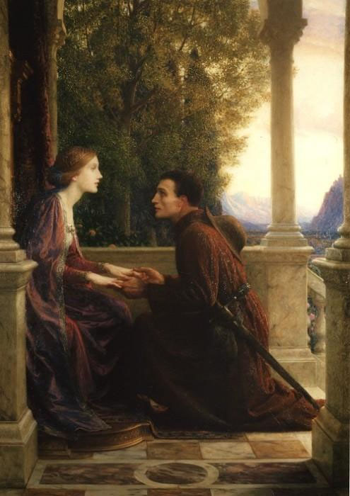Have you ever been running a published adventure, had the PCs encounter an NPC, and discovered that the NPC’s description was eight paragraphs of undifferentiated text? You remember reading through this stuff two days ago when you were reviewing the adventure, but how are you going to fish out all the little details from that wall of text? (And three scenes later, of course, you realize that everything has spun completely out of control because you forgot that the NPC was supposed to tell the PCs about the properties of the Starstone, but that was hidden away as a single sentence in the fourth paragraph. Whoops.)

Or have you been prepping your own material and found yourself wasting a lot of time writing up lengthy descriptions of your NPCs that never seem to have any real impact at the table? Are you trying to figure out a better way of organizing your NPCs so that you can just focus on the important stuff? (And so that, when your players decide to spontaneously visit the guy they met twelve sessions ago, you’ll be able to quickly pick that NPC up and start playing him again.)

Or maybe you’re really good at juggling all those little details, but you struggle when it comes to really getting into character or making each of your NPCs a unique, distinct, and memorable individual.

And maybe, as you’ve tried to find a solution for these problems, you’ve found various tools or techniques online or in How to GM books that are designed to give you richer and more evocative NPCs… but they all involve spending 5x longer prepping them.

Well, that’s what this Universal NPC Roleplaying Template is all about.

I’ve been using it for more than a decade now, slowly refining it through actual play. Generally speaking, it doesn’t take any extra effort compared to the traditional “wall of text” presentations, but it structures the NPC’s description into utilitarian categories that (a) focus your prep and (b) make it incredibly easy to use during actual play. I’ve found that I can design NPCs with this technique, lay them aside for months at a time, and then pick them back up again smoothly in the middle of play without any review: Instead of trying to parse several paragraphs of dense text, the template will guide you directly to the information that you need.

**USING THE TEMPLATE**

**Name**: Self-explanatory. (Or, at least, I hope it is.)

**Appearance**: Essentially a boxed text description that you can use when the PCs meet the the NPC for the first time. Get it pithy. 1-2 sentences is the sweet spot. Three sentences is pretty much the maximum length you should use unless there is something truly and outrageously unusual about the character. Remember that you don’t need to describe every single thing about them: Pick out their most interesting and unique features and let your players’ imaginations paint in the rest.

**Quote**: I don’t always use this entry, but a properly crafted quote can be a very effective way to quickly capture the NPC’s unique voice. Generally speaking, though, all you want is a single sentence. You should be able to basically glance at it and grok the voice. (Special exception if the character’s voice is “rambling old man”.)

**Roleplaying**: This is the heart of the template, but it should also be the shortest section. Two or three brief bullet points at most. You’re looking to identify the essential elements which will “unlock” the character for you.

There are no firm rules here, but I will always try to include at least one simple, physical action that you can perform while playing the character at the table. For example, maybe they tap their ear. Or are constantly wearing a creepy smile. Or they arch their eyebrow. Or they speak with a particular accent or affectation. Or they clap their hands and rub them together. Or snap their fingers and point at the person they’re talking to. Or make a point of taking a slow sip from their drink before responding to questions. You don’t have to make a big deal of it and it usually won’t be something that you do constantly (that gets annoying), but this mannerism is your hook: You’ll find that you can quickly get back into the character by simply performing the mannerism. It will make your players remember the NPC as a distinct individual. And it can even make playing scenes with multiple NPCs easier to run (because you can use the mannerisms to clearly distinguish the characters you’re swapping between).

You’ll generally only need one mannerism. Maybe two. More than that and you lost the simple utility of the mannerism in unnecessary complexity. It’s not that the character’s entire personality is this one thing; it’s that the rest of the character’s personality will flow out of you whenever you hit that touchstone.

Round this out with personality traits and general attitude. Are they friendly? Hostile? Greedy? Ruthless? Is there a particular negotiating tactic they like? Will they always offer you a drink? Will they fly into a rage if insulted? But, again, keep it simple and to the point. You want to be able to glance at this section, process the information almost instantaneously, and start playing the character. You don’t need a full-blown psychological profile and, in fact, that would be counterproductive.

**Background**: This section is narrative in nature. You can let it breathe a bit more than the other sections if you’d like, but a little will still go a long way. I tend to think of this in terms of essential context and interesting anecdotes. Is it something that will directly influence the decisions they make? Is it information that the PCs are likely to discover about them? Is it an interesting story that the NPC might tell about themselves or (better yet) use as context for explaining something? Great. If it’s just a short story about some random person’s life that you’re writing for an audience of one, refocus your attention on prepping material that’s relevant to the players.

**Key Info**: In bullet point format, lay out the essential interaction or information that the PCs are supposed to get from the NPC. The nature of this section will vary depending on the scenario and the NPC’s role in it, but the most obvious example is a mystery scenario in which the NPC has a clue. Rather than burying that clue in the narrative of the NPC’s background, you’re yanking it and placing it in a list to make sure you don’t lose track of it during play. (The [Three Clue Rule](https://thealexandrian.net/wordpress/1118/roleplaying-games/three-clue-rule) applies, of course, so just because something appears in this section it doesn’t mean that the PCs are automatically going to get it.)

You could also use this section to lay out the terms of employment being offered by the Mysterious Man in the Tavern. Or to list the discounts offered by a shopkeeper. It’s a flexible tool. In some cases, it might get quite long. But try to keep it well-organized (using the bullet points will help with that). If it just becomes a giant wall of text, its purpose has been lost.

**Stat Block**: If you need stats for the NPC, put ’em at the bottom of the briefing sheet in whatever format makes sense for the system you’re running.

**DESIGN NOTES**

Way back in 2001, Atlas Games published [*In the Belly of the Beast*](http://www.amazon.com/exec/obidos/ASIN/1887801960/digitalcomi0a-20), a D20 adventure by Mike Mearls. This was a roleplaying-intense adventure featuring multiple factions trapped inside the belly of an immense demon. In and of itself, it’s a pretty awesome adventure. But it’s had a particularly enduring legacy for me because it contained the seeds of this NPC roleplaying template. Mearls broke his NPC information down into six sections: Key Information (which, in his version, was bullet points summarizing the character’s background), Quote, Background, Appearance, Roleplaying Notes, and Goals. The disadvantage of Mearls’ version is that it requires more prep work than the traditional method of prepping a character, but the basic idea of structuring the description of the NPC into utilitarian categories that were designed to be used at the gaming table was incredibly useful. (Like most good ideas, it seems simple enough… it’s just that nobody had done it before.)

I promptly absconded with it.

Over the years, I’ve refined the format and tightened its focus, developing it into a streamlined, universal template which I’ve found doesn’t take any extra effort to use, but which still brings all the benefits of the utilitarian structure. In that time I’ve used it in a wide variety of campaigns, and it’s proven itself to be a useful and flexible tool with a lot of different applications. (For example, check out the [Muse to Your Left](https://thealexandrian.net/wordpress/33839/roleplaying-games/eclipse-phase-muse-to-your-left) structure for [*Eclipse Phase*](http://www.amazon.com/exec/obidos/ASIN/0984583505/digitalcomi0a-20) games.)

**EXAMPLE: BHALTAIR MCCLELLAN**

Bhaltair McClellan is an NPC from Paradiso Countdown, an introductory adventure for the [*Infinity*](http://www.modiphius.com/infinity.html) roleplaying game that you can currently snag if you’re a backer of the game’s [kickstarter](https://www.kickstarter.com/projects/modiphius/corvus-bellis-infinity-roleplaying-game).

**Appearance:** A boisterous, round-bellied man with thick red hair that tumbles down into a beard that threatens (but does not quite succumb to) unruly excess.

**Quote:** “You should take a load off, mate. And have a drink. It won’t bring him back, but it’ll keep us all sane.”

**Roleplaying:**

* A loud and hearty laugh that comes easily.
* Somehow finds a way to use elaborate metaphors featuring Ariadnan ales regardless of the actual topic of conversation.
* Likes to slap people on the back. (If it stings, you know he likes you. If it is hard enough to make you lose your balance, you know he does not.)

**Background:** Bhaltair is Ariadnan of Caledonian stock. When he was just a young kid, his father went off to fight in a bloody frontier conflict between Caledonia and Rodina. He never came back. Bhaltair made a pledge that he would work to never see his homeworld torn apart by such senseless violence again. He became a politician and quickly discovered how difficult the dream of peace can be. When the Human Sphere returned to Ariadna, he was at first overjoyed at how it unified the planet…and then watched in horror as the Commercial Conflicts ripped his planet apart again. He lost himself in drink for a time and then, concluding that the only way to bring true peace to Ariadna was to solve the off-planet problems that were manifesting themselves there, he became a diplomat. He did not participate in the negotiation of the Tohaa Contact Treaty, but he has recently arrived to take part in the Alliance Summit.

**Key Info:**

* Although he is a fresh arrival on the EveningStar, Bhaltair had worked with Alinari a few years back when they were both stationed on Shentang together.
* Alinari roped him into working with a Tohaa named Sareelia Mogaal. They all work on the Technology Exchange Commission together and Alinari wanted to open up an “alternative channel of negotiation”.
* Alinari has been having an affair with Gudrun Vastag.

**EXAMPLE: SYR ARION**

Syr Arion appears in [*City Supplement 1: Dweredell*](http://rpg.drivethrustuff.com/product/27955/City-Supplement-1-Dweredell?affiliate_id=81207).

**Appearance:** Arion is still a man in the flush of youth: Short-cropped, jet black hair sets off his piercing blue eyes. His frame is only lightly muscled, but toned and trained. The weight of his office, however, has brought bags beneath his eyes. And the late hours his sense of responsibility brings often causes his shoulders to stoop with exhaustion. But when the Syr gathers his strength, the image of a great man remains.

**Quote:** “Just give me time to think. There must be a way.”

**Roleplaying**:

* A passionate man, but — increasingly — a weary one.
* In desperate need of friends, but years of experience and loss have taught him not to trust lightly.
* Rests his chin heavily into the palm of his hand.

**Background:** Arion’s mother died in childbirth, and he was reared as the last child of the Erradons by his father, a man whose faculties were already deserting him when Arion was born. Arion’s father believed that his brother had been killed by the Guild, and the one edict he never wavered from was that Arion should be strictly sequestered. As a result, the only true friend Arion had while growing up was Celadon, the Captain of the Prince’s Guard – a man thirty years his senior.

Despite this, or perhaps because of it, Arion dedicated himself to rigorous self-perfection: When he was not learning swordplay from Celadon, he was spending hours pouring over the musty tomes of his father’s library. He saw that his father was a poor ruler, and believed it was his place to restore the honor of the Erradons by restoring the glory of [Dweredell](http://rpg.drivethrustuff.com/product/27955/City-Supplement-1-Dweredell?affiliate_id=81207)**.**

**EXAMPLE: DEVOLA THE NAGAINA**

Devola is a character from [*The Devil’s Spine*](http://www.drivethrurpg.com/product/120025/The-Devils-Spine?affiliate_id=81207), a campaign for Monte Cook’s [Numenera](http://rpg.drivethrustuff.com/product/114133/Numenera?affiliate_id=81207). I adapted her into this format when I was running the campaign. My local players should skip this section, since I’m hoping to run this campaign again in the future.

**Appearance**: A massive serpent, 50 to 70 feet long. Her mouth is surrounded by tentacles 15 feet long, most of which have been adapted so that they end in cybernetic or bioengineered tools, syringes, or weapons.

**Roleplaying**:

* Extremely confident, intelligent, and cunning.
* Alien in thought.
* Considers non-nagaina inferior, almost inconsequential beings — useful as tools or test subjects, nothing else.
* Hoarse voice that sounds like the feeling of a slimy tendril against the back of your neck.
* Weave from the neck and shoulders. Cock head at odd angles.

**Background**: Devola is a scientist of sorts, specializing in surgical experimentation and evolutionary biology. She is far more learned in her chosen areas of expertise and far more intelligent than the vast majority of Ninth World humans.

**Key Info**:

* Does not speak to Lily. Lily does not speak in her presence. Never recognizes that Lily is even present.
* Immediately recognizes hosts of her offspring. Talks only to them if present.
* The Insidious Choir: Devola’s primary concern. She considers it a pre-eminent, excessionary threat. (See separate briefing notes.)
* Curing the Devil’s Spine: Devola will agree to remove the defender parasite from an infected character, but only if they agree to destroy the Insidious Choir’s Spinneret. In addition, she will need an impossible blade and gharolan (see next page for details.)

<https://thealexandrian.net/wordpress/37916/roleplaying-games/universal-npc-roleplaying-template>

[Rulings in Practice: Gathering Information](https://thealexandrian.net/wordpress/39651/roleplaying-games/rulings-in-practice-gathering-information)

March 15th, 2018

[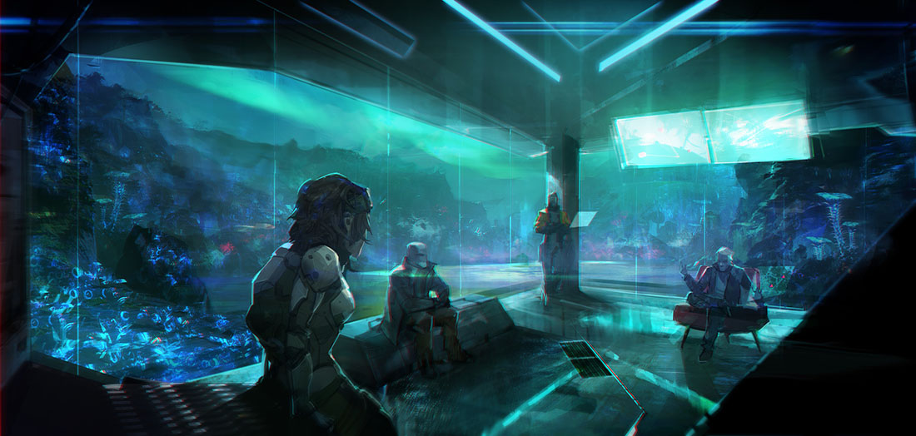](https://www.drivethrurpg.com/product/159673/INFINITY-RPG-FREE-Quickstart?affiliate_id=81207&)

As a sort of extended addendum to [*The Art of Rulings*](https://thealexandrian.net/wordpress/4238/roleplaying-games/the-art-of-rulings), this series is going to take a *specific*look at some common types of action resolution, with a particular eye on sharing the tips and tricks I’ve learned for making them work well.

We’ll start with those scenarios where a PC wants to conduct a general survey of a large body of knowledge in order to glean information that’s specifically useful to them. These tend to break down into two broad conceptual categories: **Canvassing** (talking to a large number of people to find the information you want) and **Research** (searching libraries, online resources, or other static databases for the information).

In most systems these days, you’ll find these two approaches ensconced as specific skills (making the most basic adjudication decision of which skill to roll relatively simple). For example, 3rd Edition D&D uses the Gather Information skill to cover canvassing. It’s not unusual, however, for investigation-focused systems to break them down into sub-categories. (For example, in [*Trail of Cthulhu*](https://thealexandrian.net/wordpress/35587/roleplaying-games/trail-of-cthulhu-cheat-sheet) you can use Cop Talk, Oral History, Streetwise, or even Credit Rating to canvas for information.)

Oddly, however, I can’t think of a system which actually groups these two broad categories — canvassing and research — into a single broader skill. (Perhaps because the traditional stat breakdowns derived from D&D often separate intellectual tasks like research from social tasks like canvassing?)

Unfortunately, it is slightly more common to find systems which, for whatever reason, lack one of these skills. Surprisingly, for example, [*Call of Cthulhu*](https://thealexandrian.net/wordpress/39221/roleplaying-games/call-of-cthulhu-5th-edition-revised-system-cheat-sheet) includes the ubiquitous Library Use skill for research tests, but lacks any clear skill for resolving canvassing. (Given my predilection for investigation-based scenarios, I generally find this lack incredibly annoying any more.) Defaulting to an ability check can often work, although we’ll discuss a few other options below.

Regardless of whether the PCs are researching or canvassing, the approach I take as a GM is roughly similar:

1. Summarize the approach
2. Make the key moment distinct
3. Contextualize the information

**EXAMPLE 1: D&D**

For example, in a D&D campaign where the PCs are using the Gather Information skill to canvass for information about the Vladaam crime family, I might want to deliver a chunk of information like, “There are a lot of stories suggesting a long-running feud between Sheva Callaster and the Vladaams.”

First, I’ll say something like, “You start hitting up your contacts in all the dives around the Docks.” This summarizes the approach that’s being taken to gain the information. (As opposed to, say, attending a fancy soiree in the Nobles Quarter.)

Next, I’ll identify the key moment that they find the information: “In the Inn of the Lost Sailor, you find your old sailing partner One-Eyed Pete lost in the haze of his grit addiction.”

Finally, I contextualize the information: “Pete warns you that you’d be better off staying well clear of the Vladaams. People who mess with them tend to disappear. Only person that doesn’t seem to be true for is a lady by the name of Sheva Callaster: He once saw her get jumped by three Vladaam thugs and she chased them off as if she were brushing dust from her shoulder.”

**EXAMPLE 2: ECLIPSE PHASE**

[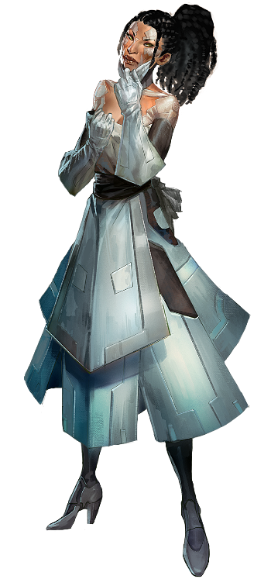](http://www.drivethrurpg.com/product/82588/Eclipse-Phase-Sunward-Hack-Pack?affiliate_id=81207&)The same general approach can be used for Research tests in [*Eclipse Phase*](https://thealexandrian.net/wordpress/38327/roleplaying-games/eclipse-phase-system-cheat-sheet-v2). Say you want to deliver a chunk of information like, “Achjima worked for Dolma Gope’s resleeving clinic.”

First, summarize the approach: “You start rooting through the corporate recruiting boards.”

Second, find the key moment: “You strike gold when you find a recent resumé for a young woman named Alicia Corey listing Achjima as a reference.”

Third, contextualize the information: “You hit the girl up. She’s turned pure infomorph because her body was ‘forcibly reclaimed’ by the local triads and she couldn’t afford a replacement. She’s eager to accept a few creds towards the new body fund and tells you all about her college days with Achjima. Sounds like Achjima has always been a radical interested in singularity seeking. She’s pretty sure Achjima is working for a woman named Dolma Gope now: Achjima was bitching about her the last time they talked.”

**THE ALTERNATIVE**

**Player**: I want to make a Gather Information test on the Vladaams.  
**GM**: Roll it.  
**Player**: 18  
**GM**: You find out that Sheva Callaster has a long-running feud with them.

**Player**: I’ll make a Research test on Achjima. 45 out of 60.  
**GM**: Achjima worked at Dolma Gope’s resleeving clinic.

I suspect the reason we want to avoid this sort of barebones alternative is fairly obvious, but the anemic [narration of outcome](https://thealexandrian.net/wordpress/38466/roleplaying-games/art-of-rulings-part-9-narrating-outcome) results in an atrophied [fiction-mechanics cycle](https://thealexandrian.net/wordpress/37976/roleplaying-games/art-of-rulings-part-3-the-fiction-mechanics-cycle) which is (a) boring, (b) divorced from the character’s experience, and (c) difficult or impossible to build off of interesting ways.

Adding just a little bit of specificity creates interest, helps to immerse the players into the game world, and provides the opportunity for both you and the players to build on the interaction. (For example, by coming back to speak with One-Eyed Pete in the future or asking Sheva Callaster for details about the assassination attempt One-Eyed Pete witnessed.)

**SUMMARIZE THE APPROACH**

Summarizing the approach is basically a statement of [intention and method](https://thealexandrian.net/wordpress/37960/roleplaying-games/art-of-rulings-part-2-intention-and-method), right?

When it comes to gathering information, I tend to have a very low specificity threshold for triggering action resolution. Usually a statement like, “I’m going to ask around town to see if anyone has heard of *greenfire*.” or “I’m going to spend the afternoon researching the name ‘Azathoth’ in the local libraries.” is more than enough. In fact, moreso than any other skill, I’ll often just allow a simple “I’m going to use X skill to do Y” to move us into action resolution (i.e., “I’m going to make a Gather Information check on the Blood of Amber.” or “I’m going to use Library Use to research the ‘cold price’.”)

Why? Well, primarily because the players don’t necessarily know where the information exists to be found. That’s why they’re making the check in the first place, right? In actual play, it’s generally not interesting for the players to play ‘guess which book you should look in to find the answer’ games.

As the GM, of course, you can always set a higher threshold for [activating character expertise](https://thealexandrian.net/wordpress/4238/roleplaying-games/the-art-of-rulings). But this is why my approach starts with summarizing the approach: Because we’ve resolved the action at a very high level of abstraction, the first thing we want to do when narrating the outcome of that action is to make it more specific. As a GM, setting this broad parameter of how the search was conducted also makes it easier to improvise the more specific details that follow.

Of course, just like any other type of action, player expertise can always trump character expertise. In other words, they’re free to get more specific in describing how they track down a particular piece of information. (For example, rather than just “searching the library”, maybe they specifically hit up the morgue of a newspaper hoping to find older stories.) In the case of gathering information, it is insanely rare for this to work against the PCs finding the information they want (and would require them to basically look for it in a way which very specifically could not possibly work). On the other hand, particularly appropriate efforts can work to their advantage (lowering the difficulty of the test or perhaps negating the need for a test entirely).

**THE KEY MOMENT**

The key moment is where the PCs gain the information they’re looking for. (So the approach is how/where they’re looking for it; the key moment is when the approach pays off.) The most important thing about the key moment is its *specificity*: You’re taking the general concept (“asking people around the Docks”, “searching through corporate job postings”, “looking in the Restricted Section of the Hogwarts Library”) and creating something unique and particular (One-Eyed Pete, the girl who worked with Achjima, *Moste Potente Potions* by Phineas Bourne).

**Framing Key Moments**: Rather than simply summarizing the key moment, however, you can instead [frame it as a scene](https://thealexandrian.net/wordpress/31520/roleplaying-games/the-art-of-pacing-part-2-scene-framing).

The simplest example is framing to the moment where the PC approaches the NPC who has the information they want. Instead of summarizing what One-Eyed Pete has to say about Sheva Callaster and the Vladaams, for example, you instead say, “You’ve heard that One-Eyed Pete knows a thing or two about the Vladaams. You find him bellied up to the bar at the Inn of the Lost Sailor.” From there, you can then simply roleplay out the ensuing encounter (which will also contextualize the information, obviously).

Handouts can also be a form of this: The information is in a newspaper article, so you explain where they found it and hand the players a copy. The actual act of reading it is where the information is imparted.

You can also frame to a challenge. For example, your Research test brings you to Alicia Corey, but convincing her to talk might require additional social skill tests. (This effectively becomes a [fortune in the middle](https://thealexandrian.net/wordpress/38570/roleplaying-games/art-of-rulings-10-fortune-positioning) technique and might be used to resolve a partial or complicated success on the Research test.)

A more elaborate version of the same is what I think of as “framing to a heist”: The PCs discover that the information they want is some place inaccessible, and now they’re going to have to figure out how to break in and get it.

**CONTEXTUALIZE THE INFORMATION**

At this point in the process you have a raw piece of data (“Sheva Callaster has a long-running feud with the Vladaams”) and you have the key moment where the PCs will gain that information (One-Eyed Pete). What you want to do is take these two pieces of the jig-saw puzzle and combine them in a way which is greater than the sum of its parts: The way One-Eyed Pete tells you the information reveals more about One-Eyed Pete, and it also gives a particular slant which colors and transforms that information.

The information would not have been the same (and would not have the same consequences) if it had come from *anywhere else*.

The importance of this can perhaps be most easily understood when it occurs in more specific circumstances:

* If the player specified a particular angle of approach, by having that choice influence the nature of the information they receive you’re building on and rewarding their creativity.
* If you’re framing to a heist, the nature of the information affects how the heist is carried out. (A kidnapped witness is very different from a file folder locked in a safe.)

And so forth. The key thing to understand is that even if you’re just going for the most basic, unprompted summarization of what happens, contextualizing the information not only makes it more interesting (and thus more of a reward for success) it will also affect (and also suggest) the ways in which the PCs can use that information.

Consider the example of Alicia Corey dishing information on Achjima’s relationship with Dolma Gope:

* Achjima was gossiping about how much he hates working with Dolma Gope.
* Achjima gave her Dolma Gope’s digital business card with an open-ended recommendation to get a job with her.
* Alicia is jealous of Dolma Gope, who she thinks (falsely) is having an affair with Achjima.

Every one of those conveys the same core nugget of information (Achjima works with Dolma Gope), but each one opens up different avenues: Achjima gossiping about how much he hates Dolma Gope might let them drive a wedge in their relationship when they meet with her, the business card might be a viable angle for gaining a meeting with Dolma Gope, and so forth.

(Note: You, as the GM, don’t think up the consequences or options of the contextualized information. That’s the player’s job. The point is that the mere act of contextualization implicitly opens up these opportunities which wouldn’t exist if you stick to the basic vanilla.)

<https://thealexandrian.net/wordpress/39651/roleplaying-games/rulings-in-practice-gathering-information>

### [Advanced Node-Based Design – Part 1: Moving Between Nodes](https://thealexandrian.net/wordpress/8171/roleplaying-games/advanced-node-based-design-part-1-moving-between-nodes)

October 3rd, 2011

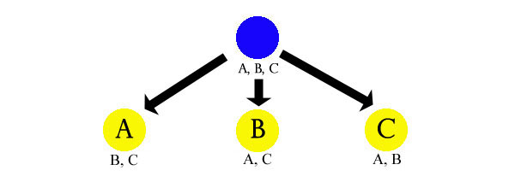

In [Node-Based Scenario Design](https://thealexandrian.net/wordpress/7949/roleplaying-games/node-based-scenario-design-part-1-the-plotted-approach) we explored an alternative to the typical plotted approach to scenario design: By designing a situation instead of a plot we create a flexible environment in which the meaningful choices of the players are allowed to flourish. And by organizing the elements of that situation into nodes we retain the clarity of the plotted approach without accepting the limitations of its straitjacket.

Now that we’ve established the basic elements of node-based design, however, I want to explore some of the tips and tricks I’ve learned in working with node-based prep.

Let’s start by taking a closer look at the fundamental structure of node-based design: How do the players move from one node to the next?

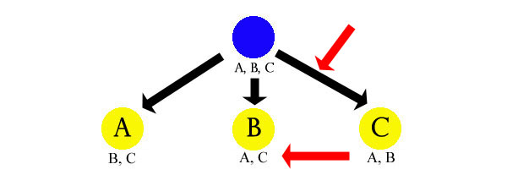

In discussing basic node-based design I defaulted to clue-based movement because (a) it’s simple; (b) it’s versatile; and (c) it clearly demonstrates just how powerful and flexible the node-based approach can be. It’s also fairly universal in my experience: Whatever other methods I may be using, the clue-based approach is virtually always part of the mix.

But it’s not the only way.

**PUSH vs. PULL**

Let’s start with a general principle.

In discussing [narrative velocity](http://roguelikedeveloper.blogspot.com/2009/10/quest-for-quests-puzzle-part-two.html) in computer games, Andrew Doull coined the terms “push” and “pull”. I find Doull’s usage of the terminology a little vague, but nonetheless useful as a basic concept: A “pull” happens when the players want to explore, experience, or discover a node. A “push” happens when the players are forced to do these things.

A pull, by its nature, requires that the players have some sort of knowledge about the node which makes it desirable for them. The appeal of the pull can take the form of a reward, an opportunity, or any other form of benefit. In a typical D&D dungeon, the pull is the promise of treasure. In a mystery scenario, the simple promise that “you might find some clues over there” is often more than enough of a pull.

A push can similarly rely on player knowledge (“rob the bank or your girlfriend dies”), but it doesn’t necessarily require it. For example, the PCs can be pushed into an encounter with the assassin hunting them (by way of ambush) without ever being aware that the assassin was coming. In other cases, the PCs’ ignorance may be the entire difference between a push and a pull. For example, they might have loved to seek out the Hidden Citadel of the Golden Empire if they had ever heard about it. But since they didn’t, it was a complete push when they randomly stumbled across it during a hexcrawl.

In practice, the distinction between a push and a pull can be somewhat muddy. This is particularly true once you start layering motivations. (For example, the PCs might be forced to investigate the recent raids by giant war parties when the duke threatens to execute them if they don’t. But once they’re engaged in the investigation, the pursuit of individual clues might still be pulls. And maybe they’d already been pulled by the giant raids because Patric’s father was killed by frost giants.)

It should also be noted that pushes don’t need to be fait accompli. The duke threatening to kill them if they don’t investigate the giant raids is certainly a push, but it doesn’t necessarily mean they don’t have the option to leave the duchy and seek their fortunes elsewhere. (Or assassinate the duke. Or bribe him to leave them alone. Or kidnap his daughter and hold her hostage until he grants them a pardon. Or any number of other things.) In other words, the game world can push at the PCs without the GM railroading them.

Pulls and pushes also don’t have to be limited to character motivations; they can also act on player motivations. If you’ve ever heard your players say “let’s find some orcs to kill so that we can level up”, then you’ve heard the siren call of the metagame pull. But this can also take the simple form of “let’s explore the Eyrie of the Raven Queen ‘cause it sounds like the most fun”.

Whether pushing or pulling or both, a node still needs to overcome a certain “gravity” in order to be explored. For some groups, this gravity is simple apathy. (You need to make the place sound a lot more interesting or threaten them with a lot more consequences before they’ll drag their sorry asses out of the local tavern.) Sometimes it’s the competition with other active pulls and pushes. (“We’d love to deal with the Temple of Deep Chaos, but first we need to make sure the Pactlords can’t breach the Banewarrens.”) Or it might be the known and suspected costs of going to the node. (“The Tomb of Horrors may contain a ton of treasure and that’s a fantastic pull… but it’s still a bloody death trap and I don’t want to go there.”)

<https://thealexandrian.net/wordpress/8171/roleplaying-games/advanced-node-based-design-part-1-moving-between-nodes>

[Art of Rulings – Part 5: Skill and Difficulty](https://thealexandrian.net/wordpress/38039/roleplaying-games/art-of-rulings-part-5-skill-and-difficulty)

November 18th, 2015

[*Go to Part 1*](https://thealexandrian.net/wordpress/4238/roleplaying-games/the-art-of-rulings)

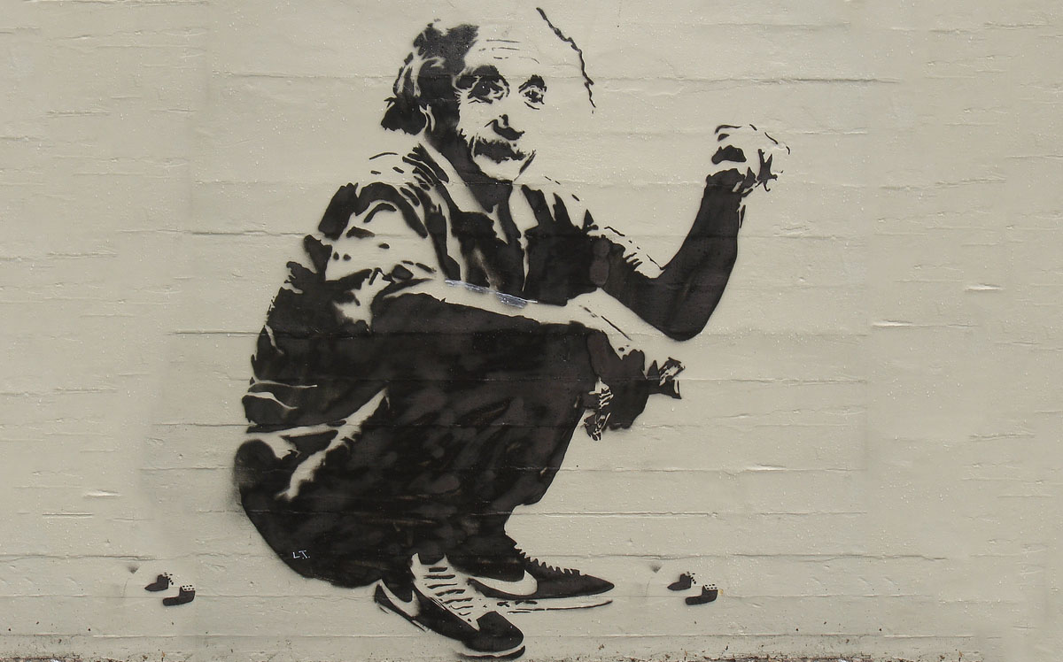

The act of turning to the game mechanics is, ultimately, an assessment that there is variability in the potential outcome of an action. At the simplest level, we are saying that there is a chance the intention will succeed and a chance that it will fail.

Before we pick up the dice, however, we should take a moment to consider the potential failure state: Failure should be interesting, meaningful, or both. If it is neither, then you shouldn’t be rolling the dice. The clearest example of this is when the response to failure is to simply try it again:

**Player**: I try to pick the lock.  
**GM**: You fail. What do you do?  
**Player**: I try to pick the lock again.  
**GM**: You fail. What do you do?  
**Player**: I try to pick the lock again.

This is the gatekeeper of mechanical resolution. If the gate is locked (i.e., failure is neither interesting nor meaningful) then you should go back to the spectrum of GM fiat and remember to *default to yes*.

(It’s equally true that *success* should be interesting, meaningful, or both. But this generally takes care of itself because the players are not going to propose actions they are not interested in achieving.)

A common mistake GMs make, however, is to think that expending resources is automatically meaningful. For example, the most basic resource that one can expend is time. So they’ll look at the lockpicking example above and conclude that the failed checks are meaningful because they chew up time. However, this lost time only becomes truly meaningful it has consequences (i.e., wandering monsters, time ticking down towards a deadline, enemies on the other side of the door having more time to prepare, etc.).

The actual process by which an action check is made is obviously dependent on the game system you’re using. I’m not going to attempt a complete survey here, but what this usually boils down to is *identifying the skill* and *setting a difficulty*.

**IDENTIFYING THE SKILL**

Identifying which skill to use is pretty straightforward: Each skill will have a description which defines its parameters. You simply need to figure out which skill’s parameters the proposed action fits, and this is usually obvious.

In some cases, you’ll find that the proposed action can fall into the purview of multiple skills. Generally speaking, you can just let the character use whichever skill is better for them. The exception is if you feel that one of the skills is less related to the task at hand than the other: Systems vary in how they handle this, but allowing the check to be made with the alternative skill at a slight penalty is usually a good one-size-fits-all solution. (Another option is to allow a skill check using the alternative skill to grant a bonus to the primary skill. Or, as in D&D 3rd Edition, allowing the character’s expertise in the secondary skill to simply provide a synergy bonus without any check.)

My personal preference is for systems that don’t have a lot of overlap in their skill descriptions. Some overlap is basically unavoidable, but being able to clearly call for a specific check generally streamlines the action resolution process by eliminating the back-and-forth of figuring out whether or not a particular skill would apply to this particular check. This is also why overlapping skills that are frequently used “in the blind” – like a Spot check to notice ambushers – are a particular pain in the ass: Since the player doesn’t know exactly what the check is being made for, they can’t let the GM know if they have an alternative skill they could be using: The GM calls for a Spot Tusked Animal check to notice the brain-eating walrus, but it turns out that the character actually has Spot Carnivorous Sea Mammals at a higher rating.

(Not an actual game. But it should be.)

Not all games have skills, of course. In most of those cases, however, you’ll generally follow the same basic procedure using attributes instead. (In many systems, skills and attributes are actually the exact same thing using different names: You take a single “this is how good I am at doing things” number and you want more detail, so you split it into a half dozen attributes. But then you still want more detail, so you split each attribute into a half dozen skills. It’s only when you get systems that freely pair skills with multiple attributes that the mechanic actually shifts. But I digress.)

**SETTING DIFFICULTY**

There are basically two ways of assigning difficulty:

1. Look at a list of difficulties and assign the difficulty by either description or analogy.
2. Start with a “default” difficulty and adjust it by considering the factors that modify that difficulty.

Some systems lend themselves more readily to one approach or the other. For example, D20 systems lend themselves to assigned difficulties and include difficulty tables that say things like, “A Hard task is DC 20.” or “A Formidable task is DC 25.” *Call of Cthulhu*, on the other hand, lends itself to adjusted difficulties by setting the default target number to the character’s skill rating so that the GM adjusts difficulty by applying a modifier to the rating.

Regardless of the system, however, you can use either technique. (And, in practice, you are likely to use combinations of both.) For example, when running D&D you could easily start with a default difficulty of DC 15 and then say, “Okay, it’s been raining and the rocks are slick, so let’s bump that up to DC 18.”

**TAKE 1 / TAKE 10 / TAKE 20**

When considering difficulty, there are three additional metrics I find useful. I’m going to use D&D 3rd Edition terminology for them because that was the system where my thinking on this first crystallized. (Players of 4th or 5th Edition may find this confusing because the designers made a really weird decision regarding the handling of “passive” checks such that the description of the [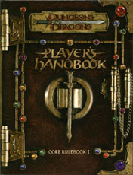](http://www.amazon.com/exec/obidos/ASIN/0786928867/digitalcomi0a-20)mechanics don’t match the mathematics of the mechanics. You’ll just have to suck it up, because I’m not going to try to jump through the broken hoops of poor mechanical design.)

**TAKE 20**: When you Take 20 in D&D, the result is calculated as if you had rolled a natural 20 on a d20. In other words, it’s the best possible success that the character is capable of achieving. It’s used in situations like our lockpicking example: The character is free to repeatedly attempt the task until they succeed, which means that we can just check the Take 20 to see if it’s a success or not.

**TAKE 10**: You can Take 10 in D&D when you’re not under any pressure. It’s the average result possible if you were rolling the dice, but the mechanic basically says “this is the level of success the character can achieve if they’re not under pressure or pushing themselves”.

**TAKE 1**: This concept is not labeled as such in D&D, but it flows naturally out of the mechanic. If you Take 1 on your roll, then it’s the worst result the character can have. If the difficulty of the task is equal to or less than the character’s Take 1, then the character will automatically succeed on that task.

Basically, these concepts break tasks down into three states: What characters succeed at without evening trying (Take 1). What they always succeed at if they make the effort (Take 10). And what they will eventually succeed at if given enough time (Take 20).

(For example, imagine that there’s something hidden in a room that requires a DC 25 Search check to find. A character with Search +5 will always find the item if they take the time to ransack the room. A character with Search +15 will find the item if they just quickly poke around the room. And a character with Search +25 will notice the item just by walking through the room.)

These concepts are generally useful in D&D (and other systems) for streamlining action resolution. But they can be specifically useful when setting difficulty by considering the type of person who would be attempting such actions and then *using them as the analogy*.

For example, I constructed these tables for D&D 3rd Edition:

**SKILLED PROFESSIONALS**

| **Skill Bonus** | **Level of Training** |
| --- | --- |
| -1 or worse | Untalented |
| +0 | Untrained |
| +1 | Basic Training |
| +5 | Apprentice |
| +10 | Professional |
| +15 | Master |
| +20 | Grand Master |
| +25 | Mythic Mastery |

**GENERIC DIFFICULTY CLASS**

| **DC** | **Task** | **Take 10 Training** | **Take 20 Training** |
| --- | --- | --- | --- |
| 0 | Very Easy | Untrained | Untrained |
| 5 | Easy | Untrained | Untrained |
| 10 | Average | Untrained | Untrained |
| 15 | Tough | Apprentice | Untrained |
| 20 | Challenging | Professional | Untrained |
| 25 | Formidable | Master | Apprentice |
| 30 | Heroic | Grand Master | Professional |
| 35 | Incredible | Mythic Mastery | Master |
| 40 | Nearly Impossible | Mythic Mastery | Grand Master |

**TAKE 10 TRAINING**: Ask yourself, “How much training would it take for someone to be able to succeed at this task as a matter of routine?” Find that level of training on the table and then add 10 to determine the DC of the check (as summarized on the *Generic Difficulty Class* table).

*Example: Even someone without any training in pottery should be able to make a simple, crude bowl if they’re shown how the equipment works, so making such a bowl should only require a DC 10 check (0 + 10 = 10). On the other hand, it takes some training before someone should be able to perform a backflip, so performing a backflip might take a DC 12 check (2 + 10 = 12).*

**TAKE 20 TRAINING**: When dealing with particularly difficult tasks the question to ask is, “How much training would a person need in order to even have a *chance* to succeed at this task?” Find that level of training on the table and then add 20 to determine the DC of the check.

*Example: An average person can’t just pick up a paperclip and pick an average lock. It takes training. So opening an average lock should be a DC 25 check (5 + 20 = 25).*

Even if you’re not performing this mental calculation in the moment, this can still be a good exercise to familiarize yourself with what different difficulty numbers really *mean* in a new system. (I find these techniques particularly useful if you’re trying to calibrate difficulty ratings for characters outside of the human norm.)

But don’t use the character as their own analogy! Setting difficulty by looking at the stats of the character attempting the action and then calculating what you want the percentage of success to be is a pernicious practice. It can seem like a good idea because you’re gauging what an “appropriate” challenge would be for them, but the end result is to basically negate the entire point of having mechanics in the first place.

[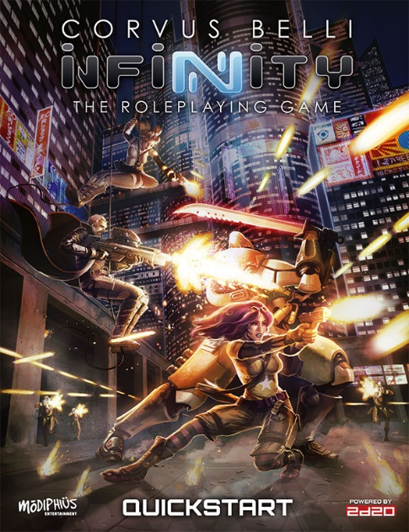](http://www.drivethrurpg.com/product/159673/INFINITY-RPG-FREE-Quickstart?affiliate_id=81207)Some systems – like D&D or *[Numenera](http://rpg.drivethrustuff.com/product/114133/Numenera?affiliate_id=81207)* – lend themselves easily to this kind of analysis. Other systems, however, will obfuscate it. This is often true of dice pool systems. For example, the 2d20 System we use in the [*Infinity*RPG](http://www.drivethrurpg.com/product/159673/INFINITY-RPG-FREE-Quickstart?affiliate_id=81207) uses a base dice pool of 2d20 which can be expanded through various mechanics up to a maximum pool of 5d20. The target number you’re trying to roll equal to or less than for a success is determined by the character’s skill rating, and the difficulty of the task is rated in the number of successes you need to roll: No matter how skilled you are, there’s no minimum level of guaranteed success. Nor, because of how the ancillary mechanics are designed, is there really a cap on the maximum success you could theoretically achieve.

You could still crank through a bunch of math and get some decent guidelines for dice pool systems like this, but in general you’re probably better off accepting the nature of the beast and using the adjust-from-default method of setting difficulty.

The 2d20 System largely sidesteps these issues, actually, because it doesn’t rely on the GM setting difficulty levels: At least 95% of the time the GM is basically deciding whether the task is of Average (1) difficulty or Challenging (2) difficulty. (Difficulty ratings of 3, 4, and 5 also exist, but are extremely rare in their application.) This is because the system is far less interested in the simple binary of passing or failing the check, and is instead intensely interested in the *margin of success* the character is achieving.

Which is exactly what we’re going to be discussing next.

<https://thealexandrian.net/wordpress/38039/roleplaying-games/art-of-rulings-part-5-skill-and-difficulty>

[Ptolus: Running the Campaign – Managing Your Supporting Cast](https://thealexandrian.net/wordpress/40089/roleplaying-games/ptolus-running-the-campaign-managing-your-supporting-cast)

June 29th, 2018

*IN THE SHADOW OF THE SPIRE*

[*Session 12A: Awkward Introductions*](https://thealexandrian.net/?p=40025)

In Session 9, the PCs found a note mentioning a mysterious “Urnest”:

*To our associate, Mister Linech Cran—*

*We are in desperate need of your most delicate shipments. As you well know, we have important work which cannot proceed apace without those shipments. Urnest assures me that the consequences will be most dire if you cannot fulfill the responsibilities you have pledged yourself to. But I am pleased to inform you that I have interceded on your behalf. You have until the third of Kadal to deliver those shipments promised to us these two weeks past.*

*Silion*

In this session, while attending the gala at Castle Shard, they encounted Commissar Igor Urnst for the first time.

*One was a tall, lean man with a mane of white hair down to his shoulders, a moustache, and goatee. He wore a monacle in one eye, contributing to his regal appearance; a dark blue tunic trimmed with gold; and a matching cloak trimmed with ermine. A heavy sword was strapped to his side and he wore several military honors upon his breast. Tee instantly recognized him as Commissar Igor Urnst, the leader of the city.*

Urnst vs. Urnest. That’s not a typo. These are two different characters.

This sort of thing is one of the reasons why it can be valuable to keep a list of names handy for random NPCs, because otherwise your subconscious is likely to be drawn back to the same options over and over again. This is also something you need to watch out for if you’re drawing material into your campaign from many different sources, as it’s quite possible to find unexpected overlaps in naming.

[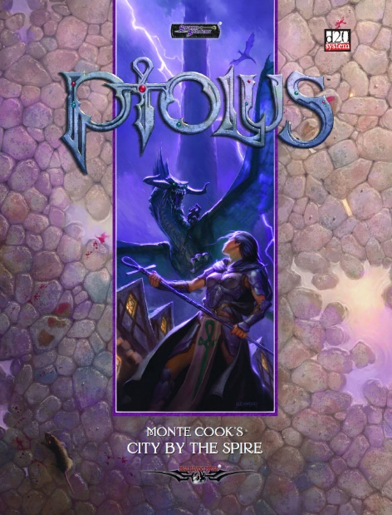](http://www.amazon.com/exec/obidos/ASIN/1588467899/digitalcomi0a-20)Neither was the case here. Both Urnst and Urnest are drawn directly from the *[Ptolus](http://www.amazon.com/exec/obidos/ASIN/1588467899/digitalcomi0a-20)* sourcebook. Just an odd quirk of the truly massive amount of material Monte Cook had generated over years of running his campaign and then injected into [that mammoth tome](https://thealexandrian.net/wordpress/2537/roleplaying-games/ptolus-running-the-campaign-graphical-resources).

I recognized the potential for confusion because, when I was reading the *Ptolus*sourcebook, I *did* become momentarily confused. (“Wait… Are these guys related? Oh, I guess not.”) I probably should have taken my cue from that and changed one of the names to something more distinct, but the thought got lost in my own labyrinthine process of prep.

But as soon as Commissar Urnst showed up in this session, Elestra’s player piped up, “Wait… Don’t we have a note mentioning this guy?” The only reward to be gleaned from my earlier confusion was that I instantly recognized what had happened and was able to quickly clarify the situation.

**A DIGRESSION ON DELIVERING META-INFORMATION**

It can be argued that the players should have simply been allowed to roll with their confusion and resolve it – or fail to resolve it – on their own. Usually, I would agree with that: Connections, relationships, and/or truths that seem “obvious” to you as their creator will not be obvious to the players, and that’s okay. It’s better for the players to figure these things out for themselves rather than having you disrupt their process of discovery.

In this particular case, however, there were only two possible outcomes: First, and most likely, they’d have laboriously dug through their trove of handouts until they found the one containing the name “Urnest”, realized their recollection was mistaken, and moved on. This was undesirable because we were in an escalating sequence designed to start the Castle Shard party off with a big [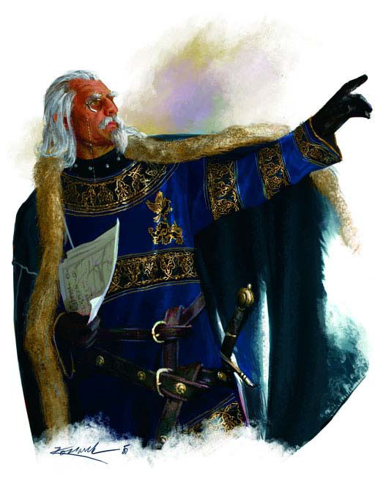](http://www.amazon.com/exec/obidos/ASIN/1588467899/digitalcomi0a-20)bang. Disrupting the escalation for a wild goose chase because I’d failed to change a confusion name had no pay-off. It was much easier to just say, “Actually, the name in that letter was ‘Urnest’,” share a laugh about Sauron vs. Saruman, and move on to the meat of the session.

The other possible outcome, which I considered extremely unlikely, was that they would take the time to find the letter and then *conclude that it was a typo*, meaning that Urnest and Urnst WERE the same person! It can be argued that this was would be a natural, organic consequence of play and it would be perfectly valid to expore it through play, most likely with some very weird and confusing interactions with the Commissar during the party trying to suss out who Silion was. Or maybe it would even result in them feeding some bad intel to Lord Zavere, creating all kinds of weird fallout in the rivalry between Castle Shard and the Commissar!

Here’s what it boils down to: You have a limited amount of time at the gaming table, and that time therefore has value. There are also opportunity costs to consider. Was a 5-10 minute search through handouts culminating in, “Oh, I guess it wasn’t the same guy.” a good use of our time? Would the (apparently null) value of that experience be worth giving up a strong, well-paced introduction to the Castle Shard party?

Other GMs might make a different assessment than I did.

**TRACKING THE NPCs**

[*In the Shadow of the Spire*](https://thealexandrian.net/in-the-shadow-of-the-spire) has a very large cast of supporting characters. When running campaigns like this – with large numbers of NPCs who have complex relationships with both each other and with the PCs – it is tremendously important that both the GM *and the players* are able to keep track of them all.

If the GM fails to keep track of his supporting cast, the campaign will founder in confusion, contradiction, and missed opportunities. The quality of the players’ interactions with the NPCs will likely also suffer as the GM struggles to portray them with consistency and depth.

As for the players, the interactions with these rich and diverse characters is where a great deal of the immersion and reward from these types of campaigns come from. Action and meaning is driven out of their relationships with the NPCs, and if they can’t track them, the campaign quickly becomes a tumultuous chaos – a great deal of sound and fury signifying nothing to them.

Ultimately, of course, the players need to take some responsibility for this. But there are a number of techniques that the GM can use to encourage and facilitate the groups’ ability to track the supporting cast; they can grease the wheels, so to speak. You might start by reviewing some of the techniques described in [*Getting the Players to Care*](https://thealexandrian.net/wordpress/4124/roleplaying-games/random-gm-tips-getting-the-players-to-care-collected), but there’s also a number of specific techniques when it comes to NPCs.

**ORGANIZE YOUR NOTES**. The first thing you need to do as a GM is to make sure your own house is in order. You need to keep well-organized and easy-to-use notes on the important NPCs in your campaign.

I keep an [*NPC Roleplaying Template*](https://thealexandrian.net/wordpress/37916/roleplaying-games/universal-npc-roleplaying-template) for each member of the supporting cast. When the *In the Shadow of the Spire* campaign started, I kept them all together in a single alphabetical file. As the complexity of the campaign grew, however, I broke them into a number of broad categories (largely based on a purely utilitarian basis, although obviously influenced by own personal understanding of how different characters – and groups of characters – interacted with each other and were likely to interact with each other). As I write this, those categories include:

* General
* Ghostly Minstrel
* Banewarrens Protectors
* Moonsilver Elves
* Chaos Cultists
* Imperial Church

In doing this, it’s important to distinguish between one-off or scenario-specific characters and campaign characters (i.e., the recurring characters who actually make up your supporting cast). If you *don’t* distinguish between them, your notes will become choked with irrelevant noise, drowning out the signal and making them more difficult to use.

Of course, it’s also important to recognize that many characters who are initially introduced for a specific scenario will *become* campaign characters as a result of how events play out and/or how the PCs interact with them. (This is similar to the process of certain NPCs “clicking” with the players that I discuss in the [*Party Planning*](https://thealexandrian.net/wordpress/37995/roleplaying-games/game-structure-party-planning) game structure, except played out on a larger scale: When the players particularly like a particular character, they’ll seek them out, become interested in their lives, and otherwise keep reincorporating them into the campaign as long as you don’t get in their way.)

**ESTABLISH NAMES EARLY AND OFTEN**: Imagine your supporting cast as a filing cabinet. Each character is an individual file folder, and the character’s name is the label on that folder. If the players lose track of characters’ names, it’s like all the labels in your filing cabinet have fallen off.

You want to make sure those names stick. So try to get a name applied to an NPC as quickly as possible. (There can be countervailing concerns, but in general nameless people doing mysterious things is a spice best used lightly.) And once the players have a name for the character, use it over and over and over again. It might make for bad prose in a novel, but defaulting to an NPC’s name (“Igor walks across the room towards you”) is I think generally superior to our normal practice of defaulting towards pronouns (“he walks across the room towards you”).

**STRONG VISUAL REFERENCES**: Giving your NPCs an actually face (in the form of a picture) is a great way to make sure they stick in the memories of your players. If you find visual reference like this, make sure to display it when the character is introduced *and get it back on the table every time they show up*.

These visual references can also be a big help when NPCs start talking to each other. Simply point to or hold up the NPC currently talking and it can go a long way to keeping conversations clear even when you’re just talking to yourself.

A couple of provisos here, though. First, better to have no picture than a picture that isn’t *right*. “She looks like this, except her hair is different” doesn’t work in practice, because the visual reference *will* override the description. (You can run into a similar problem with proxy miniatures, which is why I prefer to use purely generic options unless I’ve got the *right*miniature for the job.) As a corollary, boxing yourself in by only being willing to create NPCs that you can find visual references for is obviously going to cripple you creatively.

Second, “this guy can’t be important, he doesn’t have a picture” (and vice versa) as a form of metagame knowledge can be a serious problem. (And I find it to be so even if the players aren’t specifically acting on that knowledge; it still ends up coloring their understanding of the game world.)

So add chaff to the signal: Use pictures for NPCs who *aren’t* important. And be willing to have important NPCs who don’t have pictures. (The first proviso will naturally assist you here.)

In the absence of (and in addition to) strong visual references, finding a unique voice, physical mannerism, or strong personality are also ways to help your players clearly distinguish (and remember!) different NPCs. The *NPC Roleplaying Template*will help with this, too.

[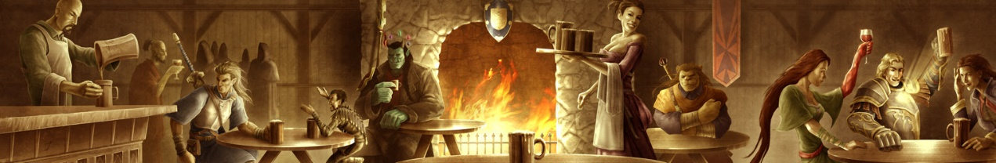](http://www.amazon.com/exec/obidos/ASIN/1588467899/digitalcomi0a-20)

**KEEP THEM ONSTAGE**: The best way for the players to become familiar with the supporting cast is, conveniently, to *use*them. Don’t “save” an NPC until it’s time for some big moment with them; give them an active life and keep them involved with the PCs. This is important not only so that the players don’t respond to the big moments by saying, “Who?” but so that your players will actually *care* about the NPCs.

The good news is that beyond a certain critical mass (and with characters that the players care about), they’ll start seeking out and creating these interactions on their own. I would know that a particular NPC had successfully clicked with my group when they’d get back to the Ghostly Minstrel and ask, “Is Jevicca here tonight?”

When prepping for a session, take a look at your supporting cast list and ask yourself if there’s anybody who the PCs haven’t seen in awhile who should be brought back onstage. Schedule events with them in your campaign status document.

Remember that you can also [reincorporate](https://thealexandrian.net/wordpress/39927/roleplaying-games/random-gm-tip-adaptation-reincorporation) members of your existing supporting cast when creating new scenarios. You should also discover that new scenarios are being born out of the evolving relationships the PCs have with the supporting cast.

**PRUNING AND FOCUSING**: On the other hand, you also have to know when to *let go* of certain members of the supporting cast.

This is true from a practical standpoint if nothing else: If all you ever do is introduce new characters to the campaign, the supporting cast *will* eventually collapse under its own bloated weight. As you (and your players) gain more experience – both generally and in terms of a specific campaign – you’ll find that the “active size” of the supporting cast you can manage will grow. But, ultimately, there’s a limit. As you add new characters, you have to be willing to let some of the old characters exit stage right to make room.

* Recognize when a character’s story is done (and there are no more stories to tell)
* Recognize when the players don’t care any more (which is not the same thing as them *hating* the character)
* Recognize when the NPC has chosen to move on (either from the PCs, from the area, or from the shared interests that drew them together)

This is a process of pruning. But it can also be thought of as a process of *focusing*. Instead of just thinking negatively (what characters can I do without?) also think positively: What characters do you want to spend more time with? What characters have interesting stories to share?

Saying goodbye to an NPC, of course, doesn’t mean saying goodbye *forever*. Old friends (and enemies) can always return.

<https://thealexandrian.net/wordpress/40089/roleplaying-games/ptolus-running-the-campaign-managing-your-supporting-cast#comments>

[Thought of the Day – Hexcrawl in the Underdark](https://thealexandrian.net/wordpress/35565/roleplaying-games/thought-of-the-day-hexcrawl-in-the-underdark)

September 19th, 2014

[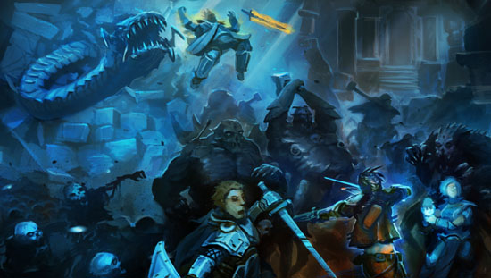](http://alexdrummo.com/)

An idea that I’ve toyed around with for years is creating a hex map for the Underdark. I still haven’t done it. But recently I’ve been running a huge technological complex for *[Numenera](http://rpg.drivethrustuff.com/product/114133/Numenera?affiliate_id=81207)*with a hex map that shares a lot of similarities with the Underdark. If the idea of running a [hexcrawl](https://thealexandrian.net/wordpress/17308/roleplaying-games/hexcrawl) through the Underdark is something you’d like to try,  I think there are a few key points to consider:

(1) What makes a hex map work is that it abstracts the actual terrain of the game world. If you’re doing a wilderness hexcrawl, you shouldn’t try to map every tree… or even every single country lane. If you do that, you’re defeating the entire point of the hex map. Similarly, if you’re designing your Underdark with a hex map you should not try to map every individual tunnel. (You *might* map major thoroughfares, the same way that major highways or rivers would be indicated on your wilderness hex map.)

(2) One key distinction between a wilderness hex map and an Underdark hex map is that, generally speaking, travel is always assumed to be possible through the side of a wilderness hex. This is not necessarily the case in the Underdark and one thing you’ll want to develop is a key indicating a minimum of three states for each side of the hex:

* **Open** (there are lots of tunnels leading from this hex to that hex)
* **Closed** (there are no tunnels leading from this hex to that hex)
* **Chokepoint** (you can get from this hex to that hex, but only by passing through a specific keyed location)

Note that the existence of a given chokepoint could also be a secret that needs to be discovered (by either obtaining the information elsewhere or perhaps by performing a detailed survey of the area).

(3) The RPG industry has developed a fairly standard “vocabulary” of wilderness terrain types. (These actually predate D&D and [were inherited from Avalon Hill’s *Outdoor Survival*](https://thealexandrian.net/wordpress/2610/roleplaying-games/reactions-to-odd-the-ur-game)when Arneson used it as a template.) These terrain types also have the benefit of being familiar to us in our every day lives: We know what forests are. We know what mountains are. And so forth. IMO, you’re going to want to develop a similarly interesting vocabulary of at least 4-5 different Underdark terrain types. And you’re going to have to figure out how to clearly communicate those differences to a group that probably doesn’t contain spelunkers (and certainly no fantasy spelunkers). The point of this, obviously, is to make the map more interesting: This both rewards exploration (a key component of any hexcrawl), but also to make the actual description of the PCs’ journey more engaging.

(4) The Underdark is fundamentally three dimensional in a way that the surface of the world is not. Keep that in mind, but don’t worry about it too much: The surface of our planet varies from 1,400 feet below sea level to 29,000 feet above sea level but we still successfully visualize it as a flat plane. Consider the minor elevation shifts I discussed in *[Jaquaying the Dungeon](https://thealexandrian.net/wordpress/13103/roleplaying-games/jaquaying-the-dungeon-part-2-the-jaquays-techniques)* and apply the same logic at a macro-scale here: You can probably make your Underdark more interesting by saying “you have to go down and then over and then up to get to there”, but vast slopes and slants and descents and climbs can be abstracted onto a two-dimensional map. So go back to Point #1 above and remember to embrace the abstraction of the hex!

<https://thealexandrian.net/wordpress/35565/roleplaying-games/thought-of-the-day-hexcrawl-in-the-underdark>

[Check This Out: Hexcrawl Tracks](https://thealexandrian.net/wordpress/25738/roleplaying-games/check-this-out-hexcrawl-tracks)

February 21st, 2013

[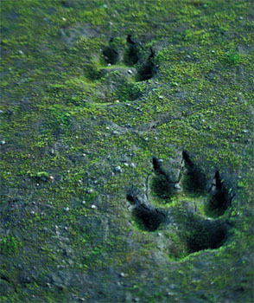](https://www.thealexandrian.net/images/20100701.jpg)Something that I touched on only briefly in my [Hexcrawl](https://thealexandrian.net/?p=17308) series was the subject of tracks: The system I use for [encounter generation](https://thealexandrian.net/wordpress/17333/roleplaying-games/hexcrawl-part-4-encounter-tables) features the ability to create random encounters, lairs, and tracks. Random encounters provide immediate obstacles and interludes while traveling; lairs spontaneously generate new locations in the hexcrawl (organically building up material along well-traveled routes as the campaign develops); and tracks are a trail that can be followed to a point of interest.

What I didn’t really extrapolate on is the fact that the concept of “tracks” isn’t necessarily limited to hoof prints in the sod. In the wilderness exploration of the hexcrawl that sort of physical spoor is most likely very common, but the concept of “tracks” really generalizes to “clue”. For example, if I generated a result of “tracks” for bandits that might include a merchant caravan in panicked disarray due to their latest highway robbery; the dead body of a bandit that was critically wounded and abandoned; a bolt-hole containing documents implicating the mayor of a local village in collusion with the bandits; and so forth.

Roger the GS recently posted “[Almost Encounters: Sights, Sounds, and Leavings](http://rolesrules.blogspot.com/2013/02/almost-encounters-sights-sounds-and.html)” which breaks this sort of thing down into some useful categories:

* Sights (“a pair of griffins flying across the sunset, many miles away”; “a brief red glow, sighted across a far-away ridge line”)
* Sounds (“snatches of shouting and song down in the valley”)
* Body Parts
* Victims
* Tracks
* Smells and Vapors
* Environment Damage
* Intentional Markings

Check it out. There are a lot of great examples [over there](http://rolesrules.blogspot.com/2013/02/almost-encounters-sights-sounds-and.html).

<https://thealexandrian.net/wordpress/25738/roleplaying-games/check-this-out-hexcrawl-tracks>

### [Random GM Tip – Using Revelation Lists](https://thealexandrian.net/wordpress/40978/roleplaying-games/random-gm-tip-using-revelation-lists)

October 29th, 2018

[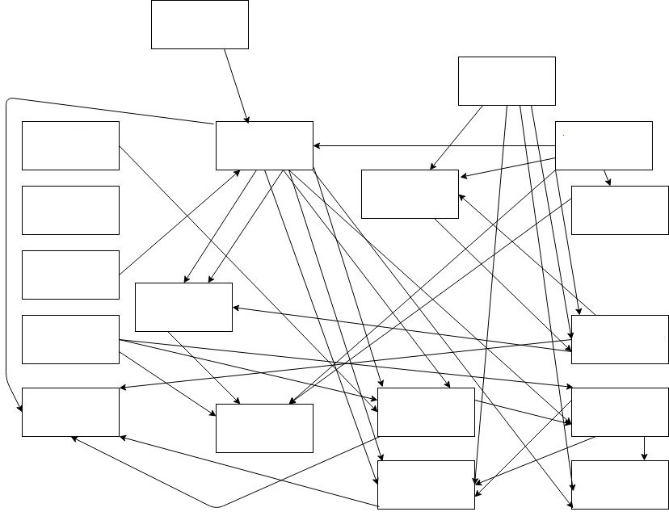](http://www.thealexandrian.net/images/20181029b.jpg)

**SPOILER WARNING!**

If you click the image above, you will see the entire scenario structure for the [Severn Valley](https://thealexandrian.net/wordpress/37389/roleplaying-games/eternal-lies-severn-valley)scenario I designed for the [Alexandrian Remix](https://thealexandrian.net/wordpress/37078/roleplaying-games/eternal-lies-the-alexandrian-remix) of the Eternal Lies campaign. If you do not wish to be spoiled on this scenario, DO NOT CLICK THE IMAGE. Its specific content is not essential for understanding the rest of this essay, and this essay contains no other spoilers for the Severn Valley scenario or the Eternal Lies campaign.

But I did want to show an example of an actual scenario structure that’s been used in actual play, and not just some deliberately over-the-top example.

What this image is specifically showing is a visual representation of the node structure of the Severn Valley scenario. If you’ve read [Node-Based Scenario Design](https://thealexandrian.net/wordpress/7949/roleplaying-games/node-based-scenario-design-part-1-the-plotted-approach), you may recall that the essay features a number of explanatory diagrams that look like this:

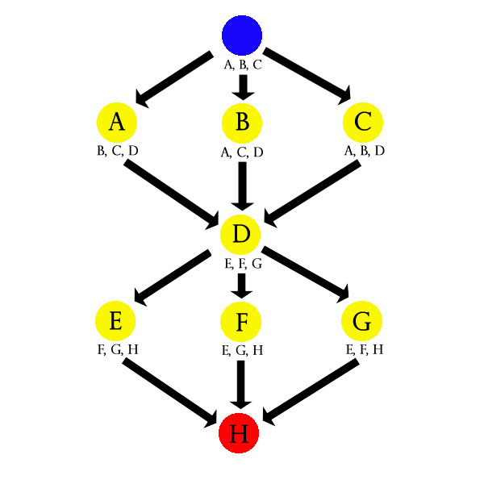

This has, for better or worse, created the misapprehension that I design scenarios using this visual motif. This is, almost without exception, not the case. (I do occasionally, during the outline stage for certain scenarios, sketch out a high-level organization to clarify the location of funnels.) And the primary reason I don’t bother with visual node diagramming is, in fact, overloaded diagrams like the one at the top of this post: That’s the structure of what I would consider a medium-complexity scenario, and the visual diagram for it is just noise… I can’t really process any meaningful data out of it and I’m the one who wrote it.

So how do I organize these scenarios?

Text-based **revelation lists**.

I discuss revelation lists in the [Three Clue Rule](https://thealexandrian.net/wordpress/1118/roleplaying-games/three-clue-rule): For each conclusion that you want the PCs to make, list the clues you’re including in the scenario for it. This functions as a checklist which allows you to track their progress and (importantly!) a diagnostic tool during actual play to make sure they’re on track.

In my scenarios, they look like this:

**SCENE 1: ELVEN CORPSES**

– The Duke’s Map (Scenario Hook)  
– Encountering Mutilated Corpses (Adventure 3:The Old Forest)  
– Reports of Mutilated Corpses (Adventure 2 – Scene 4)

**SCENE 2: THE BLACK TREE**

– Tracking Drow Scouts (Proactive 1: Drow Scouts / Scene 1)  
– Map to the Black Tree (Scene 3: The Drow Camp)  
– Elven Retaliation Scrolls (Proactive 2: Elven Retaliation Squad)

**SCENE 3: THE DROW CAMP**

– Tracking Drow Scouts (Proactive 1: Drow Scouts)  
– Elven Retaliation Scrolls (Proactive 2: Elven Retaliation Squad)  
– Map of the Old Forest (Scene 4: Drow Citadel)  
– Questioning Prisoners (Scene 2: The Black Tree)

**SCENE 4: DROW CITADEL**

– Questioning Prisoners (Scene 2: The Black Tree)  
– Subverting the Crystal Ball (Scene 3: The Drow Camp)  
– Following the Slave Train (Scene 3: The Drow Camp)

**CLUE LIST vs. REVELATION LIST**

There’s basically two ways to organize lists like this: You can list all the clues a node contains or you can list all the clues that point to the node. For the sake of clearer discussion, I’m going to refer to the latter as a **revelation list** (like the sample above) and to the former as a **clue list**.

I’ll often use a clue list when outlining or developing a scenario. After coming up with the “big concept” for a scenario, my design process generally consists of writing down cool ideas for various nodes. Then I’ll think about what kind of information a node might naturally contain to point at the other nodes. For example, I might jot down:

**SCENE 2: THE BLACK TREE**

– Questioning Prisoners (to the Drow Citadel)  
– Questioning Prisoners (to the Drow Camp)  
– Drow Scouts might show up here (track to Scene 1 or Scene 3)

Once I’ve done that for all the nodes, I’ll do a quick audit for each node to make sure I’ve included three clues. If I haven’t, I’ll get proactive figuring out how I can creatively include more clues. As I actually write up the full version of each node, however, I’ll assemble the revelation list: Each clue I include in the full write-up gets listed in the revelation list under the node it’s pointing to (with a cross-reference back to where it’s found).

This allows me to double-check my design process to make sure I’ve got all the clues I need. But it’s also importance because, when it comes time to actually run the scenario, it’s the revelation list that’s essential. (I’ll have long since thrown out the clue list.)

(1) I generally don’t care if the PCs have missed the clues in their current location, but I do care intensely about whether or not they’ve missed all the clues that would enable them to find a particular node. That’s what I need to track during actual game play, and it’s also the information that’s more difficult to glean on-the-fly without a properly organized list because…

(2) The information about which clues exist in a given node is already encoded in the text. The clues are listed in the description of the node, right? Because that’s where they are.

In terms of grokking how a particular scenario “works”, though, the revelation list can feel confusing if you’re not familiar with it. For some people, it’s simply more intuitive to look at the list of clues a node contains and then follow where they lead. (This is, after all, how the PCs will conceptually work their way through the scenario.) This is one reason why, when developing the design standard for [Infinity](https://thealexandrian.net/wordpress/39768/roleplaying-games/infinity-rpg-system-cheat-sheet) scenarios of this type, I included the requirement for both a Revelation List and an Operational Summary (which would explain the sort of “guiding principle” of how the scenario was supposed to function in play).

You don’t necessarily need the Operational Summary, though. You can get the same basic effect from a revelation list: You just need to work backwards.

Look at a node and ask, “How would the PCs get there?” In other words, follow one of the clues on the revelation list back to its source node. Then repeat the process there.

For example, how would the PCs gets to the Drow Citadel in the scenario above? Well, let’s pick a random clue: Following the Slave Train from Scene 3: The Drow Camp. So we look at Scene 3 and pick a random node there: Tracking Drow Scouts from their proactive scene. Since that’s a proactive scene, it’s essentially a scenario origin point. It’s the trail head, so to speak, and from the trail we’ve followed we can see that “tracking bad guys through the Old Forest” is one approach to the scenario.

Do it again: You can also get to the Drow Citadel by questioning prisoners from Scene 2: The Black Tree. You can get to the Black Tree by talking to (or stealing intelligence from) the Elven retaliation squads operating in the area. So here we have a path that follows a trail of demihuman misery.

Do this two or three times (or more for more complex scenarios) and you’ll get a pretty good feel for the contours of the scenario structure.

<https://thealexandrian.net/wordpress/40978/roleplaying-games/random-gm-tip-using-revelation-lists>

### [Ptolus: Running the Campaign – Commentary on the Info Dump](https://thealexandrian.net/wordpress/41172/roleplaying-games/ptolus-running-the-campaign-commentary-on-the-info-dump)

November 30th, 2018

IN THE SHADOW OF THE SPIRE

[Session 17D: Shilukar’s Secrets](https://thealexandrian.net/?p=41147)



Scattered throughout the laboratory, the warren of the spider-things, and Shilukar’s bedchamber they found a large number of notes and other papers. Many of these were written in strange characters resembling those they had found upon the obsidian statues within Ghul’s Labyrinth, and these required Ranthir’s arcane arts to decipher.

The ways in which I develop and use lore handouts – of which you can see copious other examples in [my remix of Eternal Lies](https://thealexandrian.net/wordpress/37078/roleplaying-games/eternal-lies-the-alexandrian-remix), including the thousands of words dedicated to the [Books of the Los Angeles Cult](https://thealexandrian.net/wordpress/37137/roleplaying-games/eternal-lies-books-of-the-los-angeles-cult-ucla-lot) and [Savitree’s Research](https://thealexandrian.net/wordpress/37217/roleplaying-games/eternal-lies-savitrees-research) – is probably deserving of a much longer and more detailed post at some point in the future, but in the current session you can see the PCs pick up a huge dump of such handouts all at once and thus afford us an opportunity to discuss a few points of potential interest regarding them.

First: Why so many handouts all at once?

This is glossed over somewhat quickly in the journal (although highlighted in the quote I selected above), but not all of these handouts were found in a big stack: They were scattered across several different areas, and also in different spots within those areas.

The **parceled pieces** serve as a reward for exploration. (It’s more interesting to have tidbits in several rooms than it is to have one room with a big handout and then a bunch of rooms without substantive rewards.) But split up like this they also reward partialexploration: As the scenario played out, the party routed Shilukar and took possession of the lair. But the scenario could have just as easily ended with them snatching a few pieces of obvious paper off Shilukar’s worktable and then beating a hasty retreat, leaving them with only a few fragments of information.

And in either case, rather than having a monolithic block of text to read through, the players are instead left with disparate puzzle pieces which must be pieced together. This forces them to actively engage with and think deeply about the material.

There is also **mixture of function**. Some of the information in this info dump is immediately useful; it pertains to the present. Some of it elucidates the past, revealing additional details or even fully revealing the truth behind previous mysteroes. And finally, some of it hints at the distant future, foreshadowing events and interactions to which the PCs don’t currently have access (but will or may later).

Particularly when elucidating the past, note that the handouts have been customizd to **reflect actual events** (i.e., things the PCs have actually seen or, better yet, done). By referencing the actions taken by the players in the tangible form of an actual plot, you’re deeply investing in the idea that their actions matter and that they are rippling out into a wider world far beyond their immediate sensorium.

The handouts also take **different forms** of text – epistolary, the summary of books, scratched notes, research documentation, diagrams, sketches. Each form inherently encodes information differently, providing different perspectives on the game world. (This also tends to encourage the GM not to become overly didactic, which aids in creating the puzzle-like combination of information. Also: Show, don’t tell.)

In addition to the works described in full below, they also discovered The Book of Lesser Chaos, which described in detail a technomantic art known as “chaositech”.

Present in this session, but not directly included in the campaign journal, was The Book of Lesser Chaos: This was a lengthy, multi-page handout. In D&D, I frequently use these **big lorebooks**as a way of introducing new mechanics into a campaign.

Over the years I’ve found that getting players enthused about some cool new sub-system can be a bit hit-or-miss. [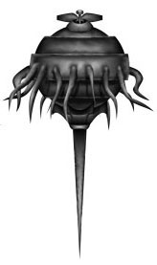](https://www.drivethrurpg.com/product/680/Chaositech?affiliate_id=81207)Often I would prep a packet of rules, pass it out to everyone with a ton of enthusiasm, and then… nada. The packet would get shuffled around for a few sessions before disappearing into a drift of paper and being forgotten.

Including the same material as a handout, on the other hand – framed with in-character material – tends to have a much higher success rate. I think it inherently makes the rules more interesting, and it also sort of demands engagement. The steps necessary to include it as a prop also encourage me, as a GM, to significantly integrate the new sub-system into the campaign world. (For example, it’s only logical for Shilukar to have a lorebook about chaositech if he’s practicing chaositech, and thus his entire lair is filled to the brim with chaositech-in-action.) This integration will also increase player engagement with the material, often stretching that engagement over longer periods of time.

Ideally, the best way to get new mechanical material fully integrated into a campaign is for it to be heavily featured in at least one session and also appear intermittently (but not consistently) over several more sessions.

But I digress. This is a different topic for another time.

<https://thealexandrian.net/wordpress/41172/roleplaying-games/ptolus-running-the-campaign-commentary-on-the-info-dump>

### On the Top Ten Sandbox Locations.

[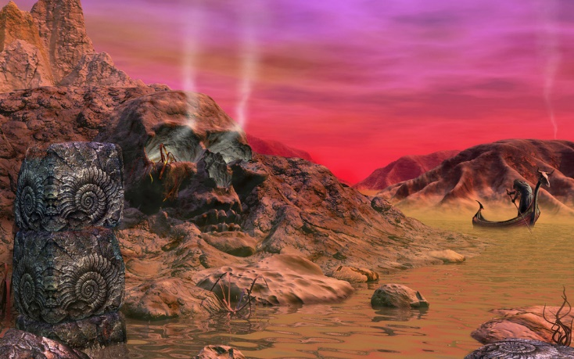](https://c1.staticflickr.com/5/4149/4998185654_ecefb6cf4d_b.jpg)

You're in a D&D sandbox, you look around and find:  
  
10. A giant rock carved like a skull. Cultists are rumored to lair there, and at night, sometimes the eyes glow as if it is possessed (or more likely that torchlight is reflected). Perhaps there are many levels of this dark place below.  
9. A wizard's tower where strange lights and sounds emanate from realms beyond. Not many people would risk their souls in a wizards tower.  
8. Rumors of great treasure and a hidden artifact are said to lie under caverns in the nearby hills. None who have survived the search have been successful.  
7. A chateau is the home of a quite dysfunctional royal family with such wealth and power!  
6. An old house, upon a hill. It's said to be haunted, those are just childrens tales. Yet people have gone missing and there are sometimes mysterious comings and goings.  
5. A castle, ran by a reclusive old man. Rumors swirl about demons and blood magic being performed, but who can tell these days?  
4. The ancient and hidden tomb of a malign creature. Those who have found it and returned, speak of death and horrible traps and mysteries.  
3. In the nearby foothills are large buildings, several of them, of primitive make. Sometimes, if you watch, you can see a large shadow of some creature. Trolls or giants perhaps, surely. You've heard of the raids nearby.  
2. A ruined moathouse, falling apart. Be careful of the large toads and collapsed roofs.  
1. A small keep, with good folk, an amusing village idiot, and a respectable brick wall. It's also possible their ale is both well-brewed and affordable. They also are rather fond of folks, who happen to be of a certain sort of miscreant or wanderer. There's surely a cleric around, but I wouldn't trust him.

<http://hackslashmaster.blogspot.com/2019/01/on-top-ten-sandbox-locations.html>

### On the Top 10 Crypts

The top ten styles of crypts for your adventurer to rob. Make it like a Turduken, and put different crypt types within each other like Matrioskha dolls.  
  
A corpse is totes inconvenient. I mean, it's not a person, it has no use, and yet it is pretty important right? What do you do with all those corpses?  
  
[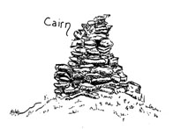](https://2.bp.blogspot.com/-2aS88nhYCWU/XCB8gYGWZPI/AAAAAAAAFI4/BEcpFrvWWQE6wl0i9A6J_GmD4Cd4kwadACLcBGAs/s1600/cairn.jpg)10 Cairn. Well, I guess if we drag it over there and cover it with rocks that will be good. Plus when you carry the rocks, you can get rid of all the feelings, because you're carrying heavy rocks. But you know, you deserve to be exhausted. After all, you're still alive.  
  
[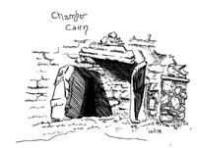](https://3.bp.blogspot.com/-nGsZ1w9peUU/XCB8eOOSASI/AAAAAAAAFIg/IziuCKcHgpAG2pCMpoDtXC6Alm4yZ6jVQCLcBGAs/s1600/Chamber%2BCairn.jpg)9. Chamber Cairn. After a while you are probably *preeety good* at moving rocks. The next step is to cover the room the dead person is in with rocks. You can still visit this way. And yet. . .  
  
[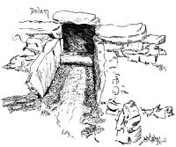](https://1.bp.blogspot.com/-anc6NgYJGtQ/XCB8e3VnO5I/AAAAAAAAFIk/faQoWMYk9goRxRM-h_7UBqHzKZRox_rXQCLcBGAs/s1600/Dolem.jpg)8. Dolems, because even the dead don't like the rain. It's a separate chamber, kind-of. Merges right with the entrances, usually through a slight change or alteration of elevation.  
  
[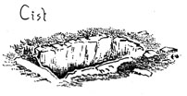](https://4.bp.blogspot.com/-uAV6n5J9Rvs/XCB8eD8hNMI/AAAAAAAAFIU/qVuWRZHw-OYY_2PelOQH9fzXVTKFxHb3wCLcBGAs/s1600/Cist.jpg)7. Cist, A hole with stone walls, or a stone coffin set in the ground. Bones lie exposed to the weather or covered in the cist.  
  
[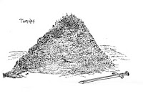](https://3.bp.blogspot.com/-1-We2DuRUhs/XCB8f7xK8WI/AAAAAAAAFI0/OwWQbXnPDrMgrt1JzFn5w8PTd145UJEEACLcBGAs/s1600/Tumulus.jpg)6. Tumulus, earth covers the dead in this burial mound, piled high over wherever the dead are stored. Frequently, large areas may be covered in some number of these, creating hills of the dead.  
  
[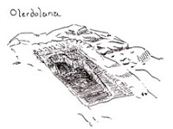](https://2.bp.blogspot.com/-9pxMOh0740I/XCB8fNbjpWI/AAAAAAAAFIs/WQKcuiyb71QeXfuSkV8Vc_4cdJjd4F0EwCLcBGAs/s1600/Olerdolana.jpg)5. Olerdolana, when the grave is carved from stone, covered, holy resting places of the dead. Easily and frequently looted.  
  
[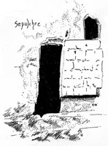](https://3.bp.blogspot.com/-3kPBmhV7dJQ/XCB8fWf19vI/AAAAAAAAFIw/6qPZO0HGj0g56CQHYC5XBYwBHcWzZJedgCLcBGAs/s1600/Sepulchre.jpg)4. Sepulchres, cut deep into the mountain, forming rooms and chambers, where christians have lain their dead in ancient times, such chambers may run quite deep.  
  
3. Catacombs, tunnels and chambers running for miles, where the dead are stored. Subterranean, an urban solution for an urban problem. What mysteries or secrets do these chambers of the deads hold? Tombs, Sarcophagi, and more can be found within their twisting passageways.  
[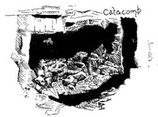](https://2.bp.blogspot.com/-bUGeVhDphWo/XCB8eBx3A7I/AAAAAAAAFIY/HJVr46iUFYYOeNTWY9wLjTTY_WWSy3rQgCLcBGAs/s1600/Catacomb.jpg)  
[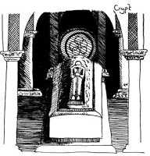](https://1.bp.blogspot.com/-cnkuz5hjF9I/XCB8eizqyUI/AAAAAAAAFIc/RRE-E-MHtNsY_AkNppIcaup-IC64lKxoACLcBGAs/s1600/Crypt.jpg)2. Crypts, a stone chamber that lies beneath the ground, where the dead are interned, vaulted for strength, and frequently near churches, though the church claims it doesn't use such work for necromancy, still the dead rise, no?  
  
[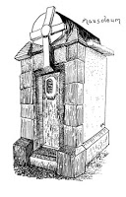](https://2.bp.blogspot.com/-Kcf2ajKGAMs/XCB8e6h1WSI/AAAAAAAAFIo/r1iJO9p5HUo5Uhf4eVGAFoy8KlDQfUOSwCLcBGAs/s1600/Mausoleum.jpg)1. The Mausoleum, a building, a home for the dead above the earth, secrets of lost lineages can lie within.  
  
Now that you've seen each of these types of tomb, it should help you be able to describe and reference your knowledge during play.  
  
This post is [Patreon supported](http://www.patreon.com/hackandslash)! Come join our community and check out all the cool stuff we having going on, and be one of the great people who's making sure more stuff like this is coming your way in the future. You'll get free stuff, High Definition images for your VTT games and more!  
  
All of the above are drawn by me. I'm also [open for commissions](http://hackslashmaster.blogspot.com/p/comissions.html)at very reasonable rates.

<http://hackslashmaster.blogspot.com/2018/12/on-top-10-crypts.html>

**On the Ecology of the Orc**

[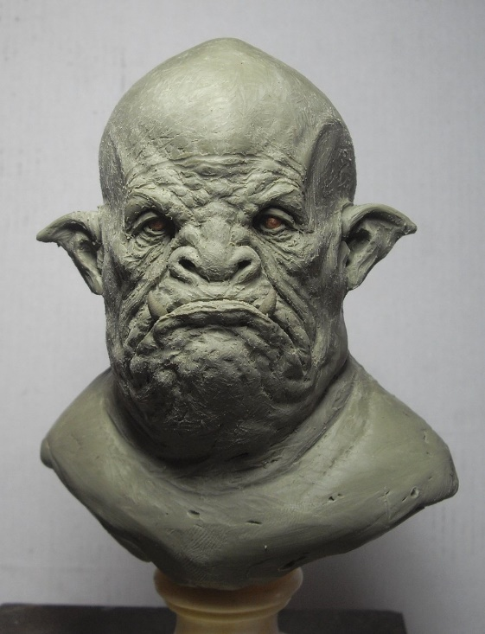](http://fc07.deviantart.net/fs71/i/2010/118/0/9/Fat_orc_WIP_by_BOULARIS.jpg)

"*They are superior to men, in all ways, except one.*" -Gorgonson, Avatar of War  
  
**Nomenclature**: Orc  
  
**Description**: Brutish, Green Skinned Humanoids  
  
**Things that are known**:

* They despise men and are hated by elves

**Rumors and other whispers in the dark**:

* There is no difference between man and orc. Orcs that live in cities *become* men, just as men who live in the wild become orcs. It is a dark secret, full of shame, and hidden from the elves and dwarves.
* It is said that sudden shock or extreme stress can cause a human to become a semi- or half-orc
* Orcs are giant aggressive plants
* Orcs are from another world, near the end of it's life-cycle. They were the only race to flee to our world, proof that brute force is the ultimate survival trait
* Orcs are the reincarnation of wicked dwarves
* Orcs are creatures of fae, born male
* Orcs are the cancer of the world, they are corrupted growth, festering in unseen places. They have no gods before them, gods being a projection by other races. The "one eyed" they worship is their singular purpose, to grow until the whole world suffers and dies
* The orcs are a forgotten placeholder, a bookmark that was never removed due to the gods own destruction
* Orcs are what happens when teen mothers drink during pregnancy in a fantasy world
* They are the next devolutionary step, one step further down from the result of elves breeding with apes to make humans. They are the coming dominate race, a cosmic secret only a few know.
* Orcs are not a separate race, but instead *all elves wearing masks*
* The brain chemistry of an adult orc is unstable. They require proteins from intelligent creatures to survive, and these proteins are better absorbed in the adrenalin rush of life or death. Stress, both physical and mental retards the breakdown process, as does intense anger and hatred. The only hope for a peaceful orc is self-mortification, extreme exercises, and a complex or possibly magical diet
* They are simply angry over centuries of bigotry
* Orcs are an escaped modular-adaptive-lifeforms, The life-form mimicked the most successful species, which at the time was neanderthal man. They evolved into their current stable state, their natural traits (fear of magic, power worship, shamelessness and fecundity) are outgrowths of this
* "Orc" is just a derogatory term for people suffering from force-field mutations
* Orcs are cruelty of dreams and foul thoughts made flesh. They cannot be slain, for doing so only creates more orcs. Their elimination requires unconditional human peace
* Orcs are the result of humans consuming troll flesh. It is all too easy to feed a large army with troll flesh, no matter how dire the consequences. Halflings turn into goblins. Elves turn into Bugbears, Gnomes and giants find the flesh deadly to consume. Mermaids turn into Sea hags.
* Orcs are the reflection of man from a once distant dimension merged with ours. Neither can achieve their potential while the other exists, and this is knowledge only the orcs have. Killing humans is a deeply spiritual duty for even an Orc, even if it's not something they eloquent often.
* Orcs are symbiotic with humans, linked by the whim of the gods. Every human has his opposite orc, when one dies, the other dies as well. Should a linked pair meet, they merge to create a new creature, a 'half-orc'. Sages say, a true neutral half-orc is destined to end the conflict, though the nature of the reckoning is debated
* Orcs are mutant elves, caused by the influence of iron on their reproduction
* Orcs are an alloy of goblins and humans. When they are burned together in a cramped space, the adaptability of humans is fused with the violent tendencies of goblins. Orcs lord over goblins because they consider themselves the next step up. There are rumors orcs could be 'broken down' into their base components, but goblins, orcs and men all agree this is likely a terrible idea.
* Orcs are scaled, cyclopean, fish-lipped monsters. They fire a ray beam from their single terrible eye, based on the color of orcs.
  + Some say that this is because the orcs were slaves to the eye tyrants, the first of whom was a mad sorcerer, who gave up his humanity to become a floating head. He then created many different cyclopean creatures, orcs being the lowest.
* A druid once desired peace, so he created a spell to remove all negative emotions, motives, and energies from humans and demi-humans. Sadly, his drug use had addled his brain and the casting was corrupted. Instead of removing the emotions, he made them manifest in the world. Worse still, humanoids retained all their basic motivation (excepting a few races on Krynn). Every orc is the hate, envy, lust, greed, violence, gluttony, and sloth of a living humanoid made manifest. Every time a human is born, a new orc is born that gives little thought to the humans passing
* Elves are divine spirits made manifest in flesh. They reproduce by cultivating new natural spirits. Sometimes this process gets corrupted and an orc develops. Like elves, they take form fully grown of spirit melded with matter. However they can use any matter and spirit to propagate. They murder and rape to ensure both new spirits and the raw material to install them in. They are born with the impulse to reproduce obsessively. After much pillaging, they either die or begin to settle.
  + Older orcs focus on other things: Refining their spiritual potency and eventually becoming demons, seeking out stasis and calm in nature, or perhaps becoming brood mothers who birth new warbands. Any orc will tell you it is foolish to depend on elves for anything, much less the future of the species.
* Orcs are an experiment by half-lings to create pig cheese. Results were mixed
* Orcs are descended from pigs. Or a culture obsessed with pigs. Breeding pigs, powering things with pig sacrifice. Suddenly people began giving birth to pigs. Or pig people. They were quietly enslaved and sacrificed and worshiped. This tenuous situation lasted only a while, then revolution began, and the orc as we know it today emerged.
* Orcs are manifestations of the wild places, boars and pigs and savagery sprung from something much more ancient than man.
* Orcs are the rational, revolutionary potential of mankind, freed from gods and their endless mechanisms of control. They aren't angry or violent by some intrinsic nature, they just have no patience for god-fearing, reactionary, bigoted humans. Better to put them all down
* Orcs are a symbiote race, host to a strain of fungus granting them toughness and increased strength and aggression. It makes them hunger for human flesh, but only to complete their nutritional needs. They are nihilist humans, derived from an intelligence not freed from the needs of the fungus
* Orcs are mudmen that have coagulated into solidity. Their anger is at their inability to flow and merge with the foul waste that birthed them. Slaying an orc causes it to crumble like damp earth.
  + Sites where many orcs have died, become spawning pits for mudmen
* You can use Faunal Succession to tell the length of time a body has been dead, for different creatures live off of it at different times. So it was with the titans, for the lizards feasted first, then dwarves, then elves, then humans, and finally the orcs
* Orcs are the result of casting 'reveal invisible' on invisible servants. They aren't supposed to be here and they know it
* Orcs are demonic footsoldiers and come in a variety of forms
* Orcs are invisible spirits that ride and corrupt the flesh of the dead. When risen, their flesh reforms, horribly, becoming an orc
* Orcs are a common result from exposing humans to the energies of the underworld till they are driven mad. One human becomes a hundred orcs as their personality spliters and manifests in reality. The leaders and spellcasters are the larger chunks of the original personality. The original can be unthinkably powerful, and is often well protected, because it is said if you kill it, all the others will cease to exist
* Orcs are what happens when you feed elves after midnight
* Orcs were the largest and most organzied bandit gang in the world, transcending cultures and borders. It has long ago collapsed, but many hold to their traditions, pig-like masks, savage dress, and horde tactics
* Orcs are a tool of the gods to curb population growth. When successful, they turn on each other, leaving areas depopulated
* Paladins sometimes raise orc troops, but must provide an opponent. Sport is not enough, their violent nature is too much, starting riots over slurs, bad calls, or injuries. Respect for brute force and eye for an eye runs deep
* Orcs are from a twisted mirror of the real world. In the dark world, they fight and murder and die in 'cities' of the real world. When an orc dies, another bursts from it's skull 9 days later. They are summoned into this world by sorcerors in foul rituals, but they are never under the sorcerer's control. They only answer to the ork king in the heart of the dark world. The ork king wishes for nothing more than to be freed from his prison
* They are frankenstine like bipedal pigs, their eyes hide no intelligence that you would wish to use speech to communicate with, and they are surrounded by an aura of flies. They are said to follow, ant-like, a massive queen ork
* Orcs are perfected elves, without vanity and with motivation. Everything that orcs are, is what an elf was meant to be
* Orcs are all little pieces of different gods, eternally at war with each other
* Orcs are the broken parts of a singluar large being, their low-level species-wide telepathic bond allows one orc to fill in for another that is absent. Their odd bumps and pits are indications of the marks where they join
* Orcs are a natural phenonom that exists outside the natural order to support it. They clear away the dead brush and allow new, stronger, creatures to take hold. Comfort and stagnation call to them, their presence an irritant. They will not leave these blights till they are burned, any more than you would leave rotten food in your cupboard
* Orcs are the shameful creations of dwarves.
  + To understand this, you must understand dwarves. To reproduce, they carve each other from different kinds of stone (Granite, marble, basalt). This is why the dwarves dig, to make more dwarves. But that is also their downfall, because sometimes they dig too deep. Throughout the ages, several dwarf clans attempted to 'improve' on the dwarf. Gnomes were forged from Clay, Sandstone, and limestone. Azers were cast from molten bronze, but once completed move to the plane of fire, never to return. Orcs are made from pig iron, and turned on their creators, driving them out and killing those left. They opened the passages to the deep and sealed the entrances and forge new orcs to this day. They raid for iron and more iron to propagate as far and deep as they can
* Orcs are created slave soldiers. All their traits that would be non-adaptive for their environment, make them better soldiers and less threatening to their creators (Stupidly brave, easy to bully, Malthusian fecundity, fast life cycle). "Following orders" isn't an excuse, but a genetic imperative. Excess orcs are sent away to live off the enemies land, or abandoned. Female orcs are breeding machines, that rarely leave their pits. They must be supported by human races, since the orcs aren't capeable enough farmers to feed themselves.
* Orcs are simply humans exposed to unhealthy space radiation. This causes them to give into their base desires, and wish to drain the ID from humans, via crude eldrich trepanning. Those who survived became orcs themselves, but sterile. Sometimes matriarchs would gain enough ID from humans that they would become sated and give birth to horrible creatures.
* Orcs are driven by a vice, while different in each it is inescapable. Wrath is the most prevalent, as they tend to kill those who are not wrathful themselves. Greed, pride, lust, and envy exist in smaller numbers, accounting for orcs of subterfuge and cunning. Slothful orcs are the most rare
* Each race was crafted from a different element. Humans from water, elves from wood, dwarves from metal, gnomes from earth and orcs from fire. Halflings are not original, crafted perhaps from the void. When the creators craft a species from air, it will mean a fundamental change in the world
* Half-orcs are sometimes called 'forks' because of their split from both human and orc
* Half-orcs aren't orcs, but the spawn of humans and animals
* There are no orc females. They procreate by impregnating females of other species. Brith usually kills the mother. The offspring is always full blooded orc
* Orcs are the insurance plan of the gods against the outsiders. You wouldn't bet on humans, dwarves, or elves to save the world? But a horde of orcs?
* There are only female orcs. In fact, elves have 1 male and 2 female sexes, with the other female sex being orcs. A pairing of two elves always produces elves, but a paring of orcs and elves produces either a male elf or a female orc. There is a very low chance of an elf/orc coupling producing a male elf, so most outsiders don't even realize that they are the same species
* Ors just are. Nobody made them. They have no destiny. Their rage comes from the fact that the gods hate them and keep trying to kill them like they are weeds
* Before the empire collapse, the Orchulli clan took to bandrity and cannibalism in order to survive. Once discovered, they were locked in their house and burned alive. Later, tunnels were discovered beneath the celler. It was assumed that this was an escape route, but it just led deeper and deeper into the dark, joining the natural caverns below. The clan mated and bred with what they found below and have been returning to the surface ever since
* Ancient scrolls contain the ritual to make elves into orcs, but as the population of elves thinned the knowelege was lost. So the ritual has been adapted to work on humans, and even mud in some cases. A poorly worded wish may be the origin of female orcs
* Orcs are autistic, with limited socializing, language and tool use, but well versed in agression and tactics. They long to find their place in the pack and respond poorly to traits they precieve as weak, such as tenderness and kindness. Some may form attachments to pigs and wolves stronger than to their careers or others of their kind

Orcs are not cultured. Here are a variety of ways orcs are born. They spring forward fully-formed, able to speak and kill

* Any man painted with blood and committing murder that stays away from the sun for a full day becomes an orc
* Any orphan who drinks from a sewer will change into an orc
* After battle, orcs excrete an iridescent black sphere, when soaked in blood an orc hatches. When soaked in demon blood a dozen orcs are born.
* Soak the ground of an ancient tree in blood, and for every wound the tree sustains, it will bud an orc in revenge
* When the teeth of demons are hurled to the ground, they explode and orcs with weapons made from bone leap to battle
* Dogs made to drown in salt water and then left in the lake cause orcs to spawn from the now fouled water
* Orcs have disgusting long spined tongues. After battle they use their tongue to infect the corpses, several hours later, orcs eat their way out of the recent corpse
* They are cooked in unholy cauldrons
* Everyone dies, only they *really don't*. Once you reach a certain age, you change and become an orc
* Marking any corpse with a dark, evil, rune will cause the ground it is buried under to produce orcs
* Humans who eat the flesh of the dead become orcs

Orcs have special combat techniques

* **Orc Fury**: Orcs can go into a battle rage when fighting, granting them an extra bonus to hit and damage equal to 1/2 their hit die (rounded down). This also grants them double this bonus to hit points fear and mind-affecting spells, but penalizes their armor class by 2.
* **Pack Tactics**: For every 2 orcs that attack a target, half may forgo their attack to give a +2 bonus to hit to the other orcs. If the orcs attempt to trip or grapple their opponent, their hit dice (or hit bonus) is doubled for the attempt. Orcs that are bonded with wolves or wargs master this technique
* **Boar's Charge**: If the Orc can move more than 10' to it's target, then it can strike with double chances to hit and do an additional x2 damage. Orcs that are bonded with boars or pigs master this technique
* **Boar's Heart**: The Orc is incredibly tough. It's AC is increased by one, and it does not die, until it takes double it's total hit points into the negatives, or fails it's saving throw versus death after dropping to 0 hit points or below (i.e. an orc with 8 hit points, must start saving versus death when reduced to 0 or below to stay alive. It dies when it reaches -16 hit points automatically).

**On the Ecology of the Orc**

[](http://fc07.deviantart.net/fs71/i/2010/118/0/9/Fat_orc_WIP_by_BOULARIS.jpg)

"*They are superior to men, in all ways, except one.*" -Gorgonson, Avatar of War  
  
**Nomenclature**: Orc  
  
**Description**: Brutish, Green Skinned Humanoids  
  
**Things that are known**:

* They despise men and are hated by elves

**Rumors and other whispers in the dark**:

* There is no difference between man and orc. Orcs that live in cities *become* men, just as men who live in the wild become orcs. It is a dark secret, full of shame, and hidden from the elves and dwarves.
* It is said that sudden shock or extreme stress can cause a human to become a semi- or half-orc
* Orcs are giant aggressive plants
* Orcs are from another world, near the end of it's life-cycle. They were the only race to flee to our world, proof that brute force is the ultimate survival trait
* Orcs are the reincarnation of wicked dwarves
* Orcs are creatures of fae, born male
* Orcs are the cancer of the world, they are corrupted growth, festering in unseen places. They have no gods before them, gods being a projection by other races. The "one eyed" they worship is their singular purpose, to grow until the whole world suffers and dies
* The orcs are a forgotten placeholder, a bookmark that was never removed due to the gods own destruction
* Orcs are what happens when teen mothers drink during pregnancy in a fantasy world
* They are the next devolutionary step, one step further down from the result of elves breeding with apes to make humans. They are the coming dominate race, a cosmic secret only a few know.
* Orcs are not a separate race, but instead *all elves wearing masks*
* The brain chemistry of an adult orc is unstable. They require proteins from intelligent creatures to survive, and these proteins are better absorbed in the adrenalin rush of life or death. Stress, both physical and mental retards the breakdown process, as does intense anger and hatred. The only hope for a peaceful orc is self-mortification, extreme exercises, and a complex or possibly magical diet
* They are simply angry over centuries of bigotry
* Orcs are an escaped modular-adaptive-lifeforms, The life-form mimicked the most successful species, which at the time was neanderthal man. They evolved into their current stable state, their natural traits (fear of magic, power worship, shamelessness and fecundity) are outgrowths of this
* "Orc" is just a derogatory term for people suffering from force-field mutations
* Orcs are cruelty of dreams and foul thoughts made flesh. They cannot be slain, for doing so only creates more orcs. Their elimination requires unconditional human peace
* Orcs are the result of humans consuming troll flesh. It is all too easy to feed a large army with troll flesh, no matter how dire the consequences. Halflings turn into goblins. Elves turn into Bugbears, Gnomes and giants find the flesh deadly to consume. Mermaids turn into Sea hags.
* Orcs are the reflection of man from a once distant dimension merged with ours. Neither can achieve their potential while the other exists, and this is knowledge only the orcs have. Killing humans is a deeply spiritual duty for even an Orc, even if it's not something they eloquent often.
* Orcs are symbiotic with humans, linked by the whim of the gods. Every human has his opposite orc, when one dies, the other dies as well. Should a linked pair meet, they merge to create a new creature, a 'half-orc'. Sages say, a true neutral half-orc is destined to end the conflict, though the nature of the reckoning is debated
* Orcs are mutant elves, caused by the influence of iron on their reproduction
* Orcs are an alloy of goblins and humans. When they are burned together in a cramped space, the adaptability of humans is fused with the violent tendencies of goblins. Orcs lord over goblins because they consider themselves the next step up. There are rumors orcs could be 'broken down' into their base components, but goblins, orcs and men all agree this is likely a terrible idea.
* Orcs are scaled, cyclopean, fish-lipped monsters. They fire a ray beam from their single terrible eye, based on the color of orcs.
  + Some say that this is because the orcs were slaves to the eye tyrants, the first of whom was a mad sorcerer, who gave up his humanity to become a floating head. He then created many different cyclopean creatures, orcs being the lowest.
* A druid once desired peace, so he created a spell to remove all negative emotions, motives, and energies from humans and demi-humans. Sadly, his drug use had addled his brain and the casting was corrupted. Instead of removing the emotions, he made them manifest in the world. Worse still, humanoids retained all their basic motivation (excepting a few races on Krynn). Every orc is the hate, envy, lust, greed, violence, gluttony, and sloth of a living humanoid made manifest. Every time a human is born, a new orc is born that gives little thought to the humans passing
* Elves are divine spirits made manifest in flesh. They reproduce by cultivating new natural spirits. Sometimes this process gets corrupted and an orc develops. Like elves, they take form fully grown of spirit melded with matter. However they can use any matter and spirit to propagate. They murder and rape to ensure both new spirits and the raw material to install them in. They are born with the impulse to reproduce obsessively. After much pillaging, they either die or begin to settle.
  + Older orcs focus on other things: Refining their spiritual potency and eventually becoming demons, seeking out stasis and calm in nature, or perhaps becoming brood mothers who birth new warbands. Any orc will tell you it is foolish to depend on elves for anything, much less the future of the species.
* Orcs are an experiment by half-lings to create pig cheese. Results were mixed
* Orcs are descended from pigs. Or a culture obsessed with pigs. Breeding pigs, powering things with pig sacrifice. Suddenly people began giving birth to pigs. Or pig people. They were quietly enslaved and sacrificed and worshiped. This tenuous situation lasted only a while, then revolution began, and the orc as we know it today emerged.
* Orcs are manifestations of the wild places, boars and pigs and savagery sprung from something much more ancient than man.
* Orcs are the rational, revolutionary potential of mankind, freed from gods and their endless mechanisms of control. They aren't angry or violent by some intrinsic nature, they just have no patience for god-fearing, reactionary, bigoted humans. Better to put them all down
* Orcs are a symbiote race, host to a strain of fungus granting them toughness and increased strength and aggression. It makes them hunger for human flesh, but only to complete their nutritional needs. They are nihilist humans, derived from an intelligence not freed from the needs of the fungus
* Orcs are mudmen that have coagulated into solidity. Their anger is at their inability to flow and merge with the foul waste that birthed them. Slaying an orc causes it to crumble like damp earth.
  + Sites where many orcs have died, become spawning pits for mudmen
* You can use Faunal Succession to tell the length of time a body has been dead, for different creatures live off of it at different times. So it was with the titans, for the lizards feasted first, then dwarves, then elves, then humans, and finally the orcs
* Orcs are the result of casting 'reveal invisible' on invisible servants. They aren't supposed to be here and they know it
* Orcs are demonic footsoldiers and come in a variety of forms
* Orcs are invisible spirits that ride and corrupt the flesh of the dead. When risen, their flesh reforms, horribly, becoming an orc
* Orcs are a common result from exposing humans to the energies of the underworld till they are driven mad. One human becomes a hundred orcs as their personality spliters and manifests in reality. The leaders and spellcasters are the larger chunks of the original personality. The original can be unthinkably powerful, and is often well protected, because it is said if you kill it, all the others will cease to exist
* Orcs are what happens when you feed elves after midnight
* Orcs were the largest and most organzied bandit gang in the world, transcending cultures and borders. It has long ago collapsed, but many hold to their traditions, pig-like masks, savage dress, and horde tactics
* Orcs are a tool of the gods to curb population growth. When successful, they turn on each other, leaving areas depopulated
* Paladins sometimes raise orc troops, but must provide an opponent. Sport is not enough, their violent nature is too much, starting riots over slurs, bad calls, or injuries. Respect for brute force and eye for an eye runs deep
* Orcs are from a twisted mirror of the real world. In the dark world, they fight and murder and die in 'cities' of the real world. When an orc dies, another bursts from it's skull 9 days later. They are summoned into this world by sorcerors in foul rituals, but they are never under the sorcerer's control. They only answer to the ork king in the heart of the dark world. The ork king wishes for nothing more than to be freed from his prison
* They are frankenstine like bipedal pigs, their eyes hide no intelligence that you would wish to use speech to communicate with, and they are surrounded by an aura of flies. They are said to follow, ant-like, a massive queen ork
* Orcs are perfected elves, without vanity and with motivation. Everything that orcs are, is what an elf was meant to be
* Orcs are all little pieces of different gods, eternally at war with each other
* Orcs are the broken parts of a singluar large being, their low-level species-wide telepathic bond allows one orc to fill in for another that is absent. Their odd bumps and pits are indications of the marks where they join
* Orcs are a natural phenonom that exists outside the natural order to support it. They clear away the dead brush and allow new, stronger, creatures to take hold. Comfort and stagnation call to them, their presence an irritant. They will not leave these blights till they are burned, any more than you would leave rotten food in your cupboard
* Orcs are the shameful creations of dwarves.
  + To understand this, you must understand dwarves. To reproduce, they carve each other from different kinds of stone (Granite, marble, basalt). This is why the dwarves dig, to make more dwarves. But that is also their downfall, because sometimes they dig too deep. Throughout the ages, several dwarf clans attempted to 'improve' on the dwarf. Gnomes were forged from Clay, Sandstone, and limestone. Azers were cast from molten bronze, but once completed move to the plane of fire, never to return. Orcs are made from pig iron, and turned on their creators, driving them out and killing those left. They opened the passages to the deep and sealed the entrances and forge new orcs to this day. They raid for iron and more iron to propagate as far and deep as they can
* Orcs are created slave soldiers. All their traits that would be non-adaptive for their environment, make them better soldiers and less threatening to their creators (Stupidly brave, easy to bully, Malthusian fecundity, fast life cycle). "Following orders" isn't an excuse, but a genetic imperative. Excess orcs are sent away to live off the enemies land, or abandoned. Female orcs are breeding machines, that rarely leave their pits. They must be supported by human races, since the orcs aren't capeable enough farmers to feed themselves.
* Orcs are simply humans exposed to unhealthy space radiation. This causes them to give into their base desires, and wish to drain the ID from humans, via crude eldrich trepanning. Those who survived became orcs themselves, but sterile. Sometimes matriarchs would gain enough ID from humans that they would become sated and give birth to horrible creatures.
* Orcs are driven by a vice, while different in each it is inescapable. Wrath is the most prevalent, as they tend to kill those who are not wrathful themselves. Greed, pride, lust, and envy exist in smaller numbers, accounting for orcs of subterfuge and cunning. Slothful orcs are the most rare
* Each race was crafted from a different element. Humans from water, elves from wood, dwarves from metal, gnomes from earth and orcs from fire. Halflings are not original, crafted perhaps from the void. When the creators craft a species from air, it will mean a fundamental change in the world
* Half-orcs are sometimes called 'forks' because of their split from both human and orc
* Half-orcs aren't orcs, but the spawn of humans and animals
* There are no orc females. They procreate by impregnating females of other species. Brith usually kills the mother. The offspring is always full blooded orc
* Orcs are the insurance plan of the gods against the outsiders. You wouldn't bet on humans, dwarves, or elves to save the world? But a horde of orcs?
* There are only female orcs. In fact, elves have 1 male and 2 female sexes, with the other female sex being orcs. A pairing of two elves always produces elves, but a paring of orcs and elves produces either a male elf or a female orc. There is a very low chance of an elf/orc coupling producing a male elf, so most outsiders don't even realize that they are the same species
* Ors just are. Nobody made them. They have no destiny. Their rage comes from the fact that the gods hate them and keep trying to kill them like they are weeds
* Before the empire collapse, the Orchulli clan took to bandrity and cannibalism in order to survive. Once discovered, they were locked in their house and burned alive. Later, tunnels were discovered beneath the celler. It was assumed that this was an escape route, but it just led deeper and deeper into the dark, joining the natural caverns below. The clan mated and bred with what they found below and have been returning to the surface ever since
* Ancient scrolls contain the ritual to make elves into orcs, but as the population of elves thinned the knowelege was lost. So the ritual has been adapted to work on humans, and even mud in some cases. A poorly worded wish may be the origin of female orcs
* Orcs are autistic, with limited socializing, language and tool use, but well versed in agression and tactics. They long to find their place in the pack and respond poorly to traits they precieve as weak, such as tenderness and kindness. Some may form attachments to pigs and wolves stronger than to their careers or others of their kind

Orcs are not cultured. Here are a variety of ways orcs are born. They spring forward fully-formed, able to speak and kill

* Any man painted with blood and committing murder that stays away from the sun for a full day becomes an orc
* Any orphan who drinks from a sewer will change into an orc
* After battle, orcs excrete an iridescent black sphere, when soaked in blood an orc hatches. When soaked in demon blood a dozen orcs are born.
* Soak the ground of an ancient tree in blood, and for every wound the tree sustains, it will bud an orc in revenge
* When the teeth of demons are hurled to the ground, they explode and orcs with weapons made from bone leap to battle
* Dogs made to drown in salt water and then left in the lake cause orcs to spawn from the now fouled water
* Orcs have disgusting long spined tongues. After battle they use their tongue to infect the corpses, several hours later, orcs eat their way out of the recent corpse
* They are cooked in unholy cauldrons
* Everyone dies, only they *really don't*. Once you reach a certain age, you change and become an orc
* Marking any corpse with a dark, evil, rune will cause the ground it is buried under to produce orcs
* Humans who eat the flesh of the dead become orcs

Orcs have special combat techniques

* **Orc Fury**: Orcs can go into a battle rage when fighting, granting them an extra bonus to hit and damage equal to 1/2 their hit die (rounded down). This also grants them double this bonus to hit points fear and mind-affecting spells, but penalizes their armor class by 2.
* **Pack Tactics**: For every 2 orcs that attack a target, half may forgo their attack to give a +2 bonus to hit to the other orcs. If the orcs attempt to trip or grapple their opponent, their hit dice (or hit bonus) is doubled for the attempt. Orcs that are bonded with wolves or wargs master this technique
* **Boar's Charge**: If the Orc can move more than 10' to it's target, then it can strike with double chances to hit and do an additional x2 damage. Orcs that are bonded with boars or pigs master this technique
* **Boar's Heart**: The Orc is incredibly tough. It's AC is increased by one, and it does not die, until it takes double it's total hit points into the negatives, or fails it's saving throw versus death after dropping to 0 hit points or below (i.e. an orc with 8 hit points, must start saving versus death when reduced to 0 or below to stay alive. It dies when it reaches -16 hit points automatically).

<http://hackslashmaster.blogspot.com/2013/09/on-ecology-of-orc.html>

### On the Ecology of the Kobold

[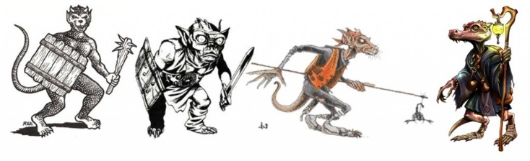](http://www.stargazersworld.com/wordpress/wp-content/uploads/2011/02/Kobold-Evolution-1024x315.jpg)  
There is a special note at the end.*  
  
"*It is the worst and best thing about living beneath the earth. The endless responsibility and pleasure of*  
*slaying the revenge of the stone.*" - Smoke  
  
**Nomenclature**: Kobolds, Cobalts, Koboldi, Knockers, The bold,  
  
**Description**: Underground demons spawned from earth  
  
**Things that are known**:

* They are small
* They ***hate*** gnomes
* They have an aversion to melee combat
* They are sensitive to light
* They have facility with traps and mechanical object
* They can see in the dark

**Rumors and other whispers in the dark**:

* They are actually halflings. When a dragon swallows a halfling whole, the resulting egg hatchlings are kobolds
* Kobolds are related to kabouter, common garden gnomes
* When moving alone through tunnels, kobolds are capable of dilating time, allowing them to reset traps faster than humanly possible
* Kobolds have a secret penchant for tipping cows. On adventurers.
* A secret breed of kobolds in the eastern mountains called Perkmandelz can turn invisible and run around with a lantern, imitating a subterranean will 'o wisp

[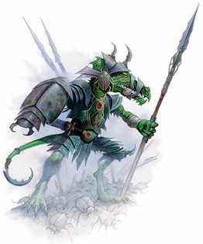](http://www.wizards.com/dnd/images/dx0127we_rotdwe_kobold.jpg)

* Kobolds are not scaled. Those are actually dermoliths: Little stones that grow in kobold skin, letting them blend in with their rocky habitat
* They are immune to petrification, because they are already petrified creatures
* Kobolds collect coins quite quickly and quietly congregate in clammy caves to count and cackle
* Kobolds feel compelled to count a loose pile of coins lying around. Then they store it in a small sack with the value written on the outside. The reason for this compulsion is unknown. It does irritate dragons who just want to sleep on coins, not little sacks filled with sacks of 100 coins each.
* A kobold can count 50 coins in a combat round
* Kobolds are the animate leavings of slain dragons.
* They lust and revenge themselves against man-races, trying to reclaim the glory of their dragon creators
* Kobolds and dwarves are related, which is why they are often found as dungeon maintainers
* Kobold horns are noted aphrodisiacs among orcs. Kobolds themselves cannot breed until their horns grow back
* A kobold's horn is regenerative, and a whole new kobold can grow from one horn. This explains the difficulty at eliminating the infestation. A single kobold can break apart it's horn and grow a whole new batch of fresh kobolds
* Kobold horns grow all over their body
* Kobolds wouldn't be the problem they are today if it wasn't for the early kobold genocide attempts. The bodies were hacked to pieces and the horns often became shattered. Each kobold then became hundreds
* Trapmaking is the highest art among the 'bolds
* Kobolds have serrated beaks, not teeth
* "This is absolute nonsense, the Kobolds of Underpnod have mobile, wrinkled faces, like disgusting little monkeys or withered, wizened halflings." -Vaziry of Pnod
* Kobolds are untamed feral dwarves, murdering and eating trespassers and hoarding ancient treasures
* Kobolds work for death and keep the damned as slaves to toil in the mines
* A dwarf is a civilized kobold that lives among humans and speaks a human language
* Civilized kobolds ("Dwarves") no longer burn in the sun, but they cannot see in darkness. Kobolds and "Dwarves" are both misshapen little old men with flinty, inhuman eyes, knobby joints, and at least one exaggerated facial feature. Beards are optional
* Kobolds turn to stone in the sun and are often collected as garden ornaments
* Kobolds are to goblins as gnomes are to dwarves
* This being the case, they are smaller, lighter, and unlike gnomes being focused on trickery, they are more direct than goblins. They use magic that causes explosions of spellfire, telekinetically hurled objects, and tunnel collapses. Even with their magic potential, the kobolds themselves are small scrawny things that rarely go into combat.
* Kobolds are very good with animals and often train small and medium creatures like boars, spiders, and giant weasels as mounts.
* They create their homes using telekinetic magic used while in a meditative trance. This allows them to function as if they were humanoid sized
* Kobolds have remarkable singing voices, however they are unlikely to share this with outsiders due to their terrible stage fright
* Kobolds are to gnomes as drow are to elves
* The viciousness and cruelty of kobolds has absolutely nothing to do with height envy.
* Kobolds are castaways from another dimension, pulled into ours by the smelting of ore. They emerge under darkness from the slag heaps
* They breath stone, swim through air and walk on water, They need air to drink, but wind is a very dangerous current. Near slag heaps you will occasionally find drowned kobolds. Cave systems and mining tunnels are more like gentle rivers and much safers
* They collect metals that they can find, hoping their shamans can use them to find a way home
* Kobolds have multiple rows of teeth which grow and grow until they die. Perhaps they are the humanoid descendants of sharks?
* Kobolds like the color blue
* Kobolds sometimes live in the forest, but have adapted to survive. They defend and mark their territory well, with guerilla patrols, snares, traps, deadfalls, and other deadly protections.
* One reason for the effectiveness of kobolds is their shamans focus on divination magic, and their easy access to communication methods (familiars, magic) and crystal balls (dug from the earth).
* In southern lands, they are seen as less evil (koboldi) and can be entertaining, due to the fact that they are always aroused and can drink to bacchanalian excess
* They fill mines with foul air, poison gas, toxic minerals, or worst of all, koboldium, the burning metal
* The kobold god has a harem of chosen kobold maidens. Many semi-divine kobold warriors are born, whose skin blunts weapons and when slain, curse the killer
* Kobolds are not only mechanically inclined, but also alchemically, skilled with black powder, incendiaries, mines, and poison gas

[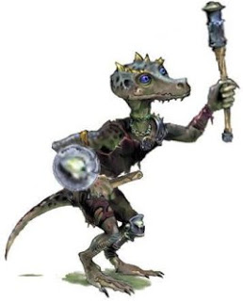](http://2.bp.blogspot.com/--PbRhvtJs4c/UG8pV1IibGI/AAAAAAAAAeg/GjBb9AlE01w/s1600/kobold1.jpg)

* The entrance to a kobold lair is always disguised
* One fated night, long ago, a very drunk, lusty, and desperate gnome had relations with a giant salamander he 'surprised' and took advantage from. The resulting spawn from this rape was several hundred kobold.
* They speak the language of insects and all crawling creatures. This is why the most poisonous and deadly don't mind being dropped by them, through muderholes on passing adventurers
* Kobolds speak no languages. They capture poisonous insects and torture them till they are only filled with rage and evil, then they release them through murderholes on passing adventurers
* Kobolds have no noses. That is why they smell terrible. ([rimshot](http://youtu.be/Frd53vbCHLg%EF%BB%BF))
* Kobold tails are a delicacy. Even kobolds themselves think so.
* Kobolds feast on dragon corpses. This is the reason for their magical nature
* Kobolds have very specific dietary needs, this is why they are never found away from underground complexes and tombs
* Kobold shamans smear gold, silver, and copper coins into their skin, forming a heavy, glittering, armored layer, as a ritual to fuel their spells and magical abilities
* A kobold that has lived an extended life and died of natural causes is reborn as what the kobolds call an Earthen One who can pass through any type of earth. This includes metals.
* Kobolds specialize on setting traps because eating tendons from the flesh of a living creatures while they scream is the greatest delicacy.
* The first kobolds emerged from the torn tooth sockets of the titans that tried to destroy the world. The pain and death of those great forms was too great to be contained, and the kobolds were forced from their gory, cracked jaws. Their word for themselves is "homeless" and their mission is to harvest parts to build a new titan home; the trouble is, they don't know how, and all they remember is pain. So they collect that in jars. But they can't actually collect it. So they hurt people and wave glass at them. It's their religion.﻿
* Kobolds have a flying relative the *Urd*. Urd are tougher, more intelligent and nastier. Their existence has nothing to do with the depredations of the kenku.
* Kobolds will hate gnomes until Garl Glittergold ceases his never ending teasing and trickery of Kurtulmak.
* Kobolds are bastard children from wild bacchanalian parties among the woodlands keepers, being a cursed combination of druids, rangers, animal companions, fey liquor, and practical jokes
* Kobolds are the immune system of an animistic living earth. The scar tissue from gouges and wounds on the surface takes the form of kobolds defending their mother
* Kobold eyes, when plucked and dried in the light of a full winter moon, will become semi-precious stones. If dice are made from these stones, they are magically loaded that shift +1 in the direction you prefer when you roll them.
* Kobolds who do enter melee often have tail attachments that they use to wound opponents. These have been know to throw black power, alchemist's fire, or substances even worse.
* They hate gnomes because gnomes are cheaters; dirty, nasty, lying, cheaters. Illusions aren't fair, traps are. Using illusions to win prank contests isn't fair. You can't win if you're dead.
* Stupid wizards. The combination of a ring of wishes, a german shepard familiar and some inadvisable things said about the usefulness of said familiar led to the kobold removing the ring from the wizards fresh corpse. The last charge is the cause of the piles of kobolds everywhere
* Kobold lariats are woven from the skin of sentient creatures. They are fascinated by hides
* If a kobold is skin, the hide dissolves into sand in 1-4 days, no matter how it is preserved
* Kobolds were originally swarming, agile, flexible, and mechanical boarding constructs for spelljammer ships. A bribe of being both made of flesh and fertile to breed was made. Their original creators, furious, rounded up all they could find and marooned them on a quarantined planet. Releasing them is a capital offense
* In ancient times, when all races were reptilian, kobolds ran the oppressive empire. All other races did their bidding. To this day they seek to manipulate and control the other races.
* In the far future, humanity seeks to save themselves from a seared sky and fouled earth. They built a time gate and sent a group to save humanity from itself. Upon arrival they became sick and only their young survived. In three generations, all was forgotten leaving a primitive culture seething with hatred for humans
* Kobolds are the progenitors of the elves, banished from the surface and forgotten by their children
* Kobolds wear lederhosen and make beer from rock
* If a kobold becomes wet he flies into a rage. A great artform is creating intricate dust and soot patterns on their skin to mimic scales
* A kobold can transform into mist on nights with a full moon. This is how they migrate from cave to cave. The mists are cursed and many believe can cause migraines, ague, and loose bowels

**Kobold special attacks and abilities**

* Agile: Kobolds are small and flexible  They can move in, around, and under other creatures bypassing them easily and immune to any bonus attacks gained via opportunity or due to fleeing
* Mob attack: Kobold receive bonuses to hit equal to the number of kobolds in melee with a target.
* Bombs: Kobolds can throw bombs with various alchemical effects (Alchemist's fire, Smokesticks, Tanglefoot bags
* Trappers luck: Kobolds can attack a player and do no damage, but moves them into a nearby trap
* Magical blast: Kobolds can generate and throw energy orbs that focus their magical force. The type of energy is dependent on the strain of kobold
* Earth step: Kobolds can meld with the earth, allowing them to disappear into the ground. They move incredibly quickly this way, reappearing anywhere within 100'
* Painful stabs: Kobold attacks do little damage but really hurt. When striking, after rolling damage, they can choose to do only 1 point of damage, but apply a -1 circumstance penalty to that players combat rolls (attack and damage) until that player receives some form of healing.
* Sluggish step: Kobolds can cover the floor with bags of their sticky poop. These cause people moving in those squares to move at half speed. Kobolds themselves are unaffected of course.

Here is a wonderful free list of Kobold traps provided by certain coastal wizards: [Kobold Traps](http://www.wizards.com/default.asp?x=dnd/we/20060127a)

**A Historical Note**  
  
Provided by [Patrick Stuart](http://hackslashmaster.blogspot.com/2013/04/on-osr-new-wave-patrick-stewart-of.html): "*The element Cobalt is actually named after Kobald, an earth spirit. The miners who dug out and smelted ores to find useful metals, which included the cobalt ore, which was poisonous with arsenic and ruined other metals, blamed Kobald when things went wrong because the spirit didn't want them down there.*

*When Georg Brandt found out what was actually poisoning the miners and ruining their ore, a new element, he named it after the spirit in tribute to the men who dug it out.*"

**A Question about Ecology**  
  
*Christopher asks: "*With these ecology rumors and such, how do you apply these to your games? Are they things that NPCs say to adventurers or are some of these ideas actually applied to change the race up and make things fresh? Or is it a mixture of both? I'm interested because I think some of these ideas are way better than the original ecology for the creatures.*"  
  
Take this information and actually change up the monsters. Then take other bits and rumors some correct and incorrect and feed them to the players. Use a group of a dozen or so redesigned and well thought out monsters for your campaign. Profit.

<http://hackslashmaster.blogspot.com/2013/05/on-ecology-of-kobold.html>

<https://thealexandrian.net/wordpress/40127/roleplaying-games/advanced-d20-rules-new-combat-maneuvers#comments>

[Advanced D20 Rules: New Combat Maneuvers](https://thealexandrian.net/wordpress/40127/roleplaying-games/advanced-d20-rules-new-combat-maneuvers)

June 27th, 2018

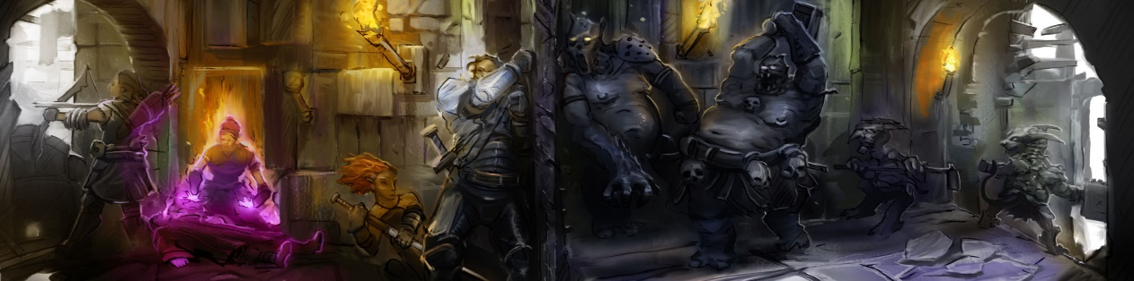

*The original 3rd Edition game came pre-packaged with a hand full of specific combat maneuvers (bull rush, disarm, etc.). I’ve always found it odd that this list was so rarely expanded upon in supplements, with designers apparently preferring to ladle on more feats instead. Over my nearly 20 years of running D20 systems, however, the*Rule Supplement*document I maintain for my personal campaigns has slowly accumulated a number of new combat maneuvers. These are presented below, along with a few expansions to the existing rules where appropriate.*

**ACTION OF OPPORTUNITY**

Instead of attacks of opportunity, characters may take actions of opportunity. An attack of opportunity can be taken as an action of opportunity, but actions of opportunity can also be used for other purposes. Feats and abilities which normally grant additional attacks of opportunity instead grant additional actions of opportunity. If a character has used all of their actions of opportunity in a round, they may still attempt an action of opportunity by using their immediate action (if it is still available to them).

**AID ANOTHER** [Standard]

If you’re in position to make a melee attack on an opponent that is engaging a friend in melee combat, you can attempt to aid your friend as a standard action. You make an attack roll against AC 10. If you succeed, you can choose to grant a +2 circumstance bonus to hit, a +2 circumstance bonus to AC, or provide flanking if you are not doing so already (regardless of your relative position).

Any character with a base attack bonus of +5 or higher may be able to offer additional assistance with a successful Aid Another check. For every 10 points that their attack roll exceeds DC 10, they grant an additional +1 circumstance bonus.

**AIM**[Attack]

When making a full attack, you can choose to sacrifice all of the attacks you could normally make and take careful aim at a specific target. On your next attack against that target, you gain a +4 circumstance bonus for each attack you sacrificed. You cannot take any other action or move more than a 5 foot step before making your attack without losing the circumstance bonus. Since you are focused on aiming, you are considered flat-footed until you make your attack.

*Quick Aim*: If you can make more than one attack as part of a full attack maneuver, you can choose to sacrifice one of your attacks in order to gain a +2 circumstance bonus to a single attack taken on the same turn. You can sacrifice multiple attacks to gain multiple circumstance bonuses, and these circumstance bonuses stack with each other.

*Example: If you can normally make four attacks when using the full attack maneuver, you can sacrifice your third and fourth attacks to gain a +4 circumstance bonus to your first attack. You could also sacrifice those attacks and gain a +2 circumstance bonus to each of your first two attacks.*

**BACK-TO-BACK** [Free]

On your turn you can choose to fight back-to-back with an ally as a free action. The ally must be within 5 feet, and must choose to fight back-to-back with you. While fighting back-to-back, you and your ally work to protect each other – shoring up each other’s defense and, literally, watching each other’s back. You and your ally make attacks at a –2 penalty while fighting back-to-back, but so long as you are fighting back-to-back you cannot be flanked.

*Note: You can fight back-to-back with multiple allies. However, in order to fight back-to-back with multiple allies, all your allies not only need to be within 5 feet of you, but within 5 feet of each other. (This clarification is only significant for odd-numbered groups wishing to fight back-to-back.)*

**BIND WEAPON / SHIELD** [Attack]

As a melee attack you can attempt to bind an opponent’s weapon or shield. Attempting to bind a weapon or shield provokes an attack of opportunity from your target.

After the attack of opportunity has been resolved, you and your target make an opposed melee attack roll. The wielder of a two-handed weapon gets a +4 bonus on this roll, and the wielder of a light weapon takes a -4 penalty. If you and your opponent are of different sizes, the larger combatant gets a bonus on the attack roll of +4 per difference in size category.

If you beat your opponent’s roll, you have successfully performed a bind on your opponent’s shield or weapon. Weapons and shields involved in a bind, whether yours or your opponents, cannot be used: Bound shields provide no armor bonus and bound weapons cannot be used to make attacks.

The instigator of a bind may end it as a free action. The target of a bind can attempt to break the bind as an attack action by succeeding at an opposed attack roll.

*Special*: Binding a weapon or shield is considered a variation of the sunder action. Characters with the Improved Sunder feat do not provoke attacks of opportunity when attempting to bind a weapon or shield.

**CALLED SHOT** [Free]

When using the attack action or the full attack action, before making attack rolls for the round, you may choose to accept a penalty on all attacks from the round in order to gain a bonus to the damage roll of your first attack. For every -2 penalty you accept you gain a +1 bonus to damage. The total penalty cannot exceed your base attack bonus. The bonus to your damage roll applies only to your first attack (even if it misses or otherwise causes no damage), but the penalty to attacks lasts until your next turn.

*Design Note: This effectively makes Power Attack a feat which improves a basic maneuver.*

**DISREGARD FLANKER** [Free]

You can disregard attacks from an opponent flanking you. When you do, that opponent doesn’t get the +2 flanking bonus when attacking you and that opponent does not provide a flanking bonus to any of its allies. Ignoring a flanker, however, provokes an attack of opportunity from that flanker, and you lose your Dexterity bonus to Armor Class against that flanker. You do, however, continue to threaten that flanker. If the flanker is out of attacks of opportunity, you can ignore the flanker (and deny the flanking bonus) with impunity.

You must make the decision to disregard a flanker as soon as the foe moves into a flanking position. You can change your decision as a free action on your turn. (You still have to disregard a flanker you can’t see.)

**DRIVE BACK** [Attack]

As a melee attack, you can attempt to drive back your opponent. In doing so, you are attacking in a way that should force your opponent to back away from you. When you perform the drive back maneuver, your opponent can either choose to move 5-feet directly away from you or remain where they are.  If they choose to move, they suffer no adverse effects. However, you can choose to follow them (also moving 5 feet) if you have the necessary movement remaining this turn. If they choose not to move, you resolve your attack against them with a +2 circumstance bonus.

The movement taken as part of the drive back does not count against your opponent’s movement for the round. Your movement does not provoke an attack of opportunity from your opponent, nor does their movement provoke an attack of opportunity from you. However, this movement may provoke attacks of opportunity from other combatants.

**ENGAGE** [Attack]

As a melee attack you can choose to engage one opponent within reach. If an engaged opponent attempts to move away from you or if they attack anyone else before your next turn, you may take an attack against them at the same Base Attack Bonus as the attack you used to engage them (this attack is in addition to any attacks of opportunity you would normally be able to take and does not count against the limit on the number of attacks of opportunity you can take each round). You gain a +2 circumstance bonus to this attack.

If your opponent attempts to make an attack of opportunity against a different character while you’re engaging them, you take your attack normally. If the attack is successful, however, your opponent must make a Concentration check (DC 10 + damage dealt). If the Concentration check fails, your opponent loses the ability to make that attack of opportunity (although they may still take an attack of opportunity later if one is provoked).

*Note: Even if you have more than one attack per round, you cannot engage a single opponent more than once (although you can engage multiple opponents at once).*

**FIGHT DEFENSIVELY**[Free]

When using the attack action or the full attack action in melee, before making attack rolls for a round, you may choose to accept a penalty on all attacks from the round in order to gain a bonus to your AC. For every -2 penalty you accept, you gain a +1 dodge bonus to your AC. (For example, by accepting a -6 penalty, you would gain a +1 dodge bonus to your AC.) The total penalty cannot exceed your base attack bonus, although characters with low base attack bonuses (less than +4) can still accept a -4 penalty to their attack rolls for a +2 dodge bonus to their AC. The penalty to attacks and bonus to AC apply until your next turn.

*Total Defense*: When using the attack action or the full attack action in melee, you can sacrifice all of your attacks and dedicate yourself to a total defense. You gain a +2 dodge bonus to your AC for each melee attack that you would normally make. (For example, if you could normally make three attacks using the full attack action, then you could gain a +6 dodge bonus to AC for using total defense as a full action.) This bonus is in addition to the normal bonus you would receive for fighting defensively or using Combat Expertise at your maximum penalty.

**INTERVENE** [Action of Opportunity]

If you are within 5 feet of an ally who is targeted by a direct melee or ranged attack you are aware of (but not an area effect), you can use an action of opportunity to attempt to take the attack in your ally’s stead. If the attack hits you, you take damage normally. If it misses, it also misses your ally. You must declare your intention to place yourself in harm’s way before the attack roll is made.

**OUT-OF-TURN-DODGE** [Immediate]

Any time a character is about to be attacked, they can give up their next turn to gain a +4 dodge bonus to their AC as an immediate action. A character must be able to apply their Dexterity bonus to AC against the attack (so a character can’t use an out-of-turn dodge while flat-footed, for example) and the out-of-turn dodge is declared before the attack roll is made. The character’s initiative does not change, they simply do not take an action on their next turn. The character gains this dodge bonus until the next time their initiative comes up after their “skipped” turn.

**PROTECT** [Immediate/Action of Opportunity]

If someone within your threatened area is about to make an attack of opportunity against a target other than yourself, you can use an action of opportunity as an immediate action to prevent them from doing so. You and the combatant attempting the attack of opportunity each make an opposed melee attack roll.

If you succeed, you use your attack of opportunity to preoccupy them and prevent them from taking the attack of opportunity. (This does not count against the total number of attacks of opportunity they may take in a round, however, and they may still take an attack of opportunity later if one is provoked).

If you fail the opposed melee attack roll, they can resolve their attack of opportunity normally. This counts as an attack of opportunity for you.

**QUICK DODGE** [Immediate/Action of Opportunity]

At any time when you are about to be attacked, you can use an action of opportunity to gain a +2 dodge bonus to AC as an immediate action. The dodge bonus is only effective against a single attack. If you can take multiple actions of opportunity in a round (through the use of the Combat Reflexes feat, for example) you can still only gain a single bonus against one attack, although you can use additional attacks of opportunity to quick dodge additional attacks.

**SPRINT** [Move]

You can sprint at twice your normal speed in a straight line as a move action. You lose any Dexterity bonus to AC while sprinting unless you have the Run feat. You cannot sprint if your maximum run speed has been reduced to three times your normal speed (due to wearing heavy armor or carrying a heavy load, for example). Sprinting twice in the same round is the same as running.

https://thealexandrian.net/wordpress/40127/roleplaying-games/advanced-d20-rules-new-combat-maneuvers#comments